UNITED STATES
SECURITIES AND EXCHANGE COMMISSION
Washington, DC 20549
FORM 8-K
CURRENT REPORT
Pursuant to Section 13 or 15(d) of the Securities Exchange Act of 1934
Date of Report: October 27, 2026
INDEPENDENT BANK CORPORATION
(Exact name of registrant as specified in its charter)
Michigan |  |  | 0-7818 |  |  | 38-2032782
(State or other jurisdiction of incorporation) |  |  | (Commission File Number) |  |  | (IRS Employer Identification No.)
98 Ottawa Ave NW  Grand Rapids, Michigan |  |  | 49503
(Address of principal executive office) |  |  | (Zip Code)
Registrant’s telephone number,
including area code: (616) 527-5820
4200 East Beltline
Grand Rapids, Michigan 49525
(Former name or former address, if changed since last report.)

Check the appropriate box below if the Form 8-K filing is intended to simultaneously satisfy the filing obligation of the registrant under any of the following provisions (see General Instruction A.2. below):
o |  |  | Written communications pursuant to Rule 425 under the Securities Act (17 CFR 230.425)
o |  |  | Soliciting material pursuant to Rule 14a-12 under the Exchange Act (17 CFR 240.14a-12)
o |  |  | Pre-commencement communications pursuant to Rule 14d-2(b) under the Exchange Act (17 CFR 240.14d-2(b))
o |  |  | Pre-commencement communications pursuant to Rule 13e-4(c) under the Exchange Act (17 CFR 240.13e-4(c))
Securities registered pursuant to Section 12(b) of the Act:
Title of each class |  |  | Trading symbol(s) |  |  | Name of each exchange on which registered
Common stock, no par value |  |  | IBCP |  |  | NASDAQ Global Select Market
Indicate by check mark whether the registrant is an emerging growth company as defined in Rule 405 of the Securities Act of 1933 (§230.405 of this chapter) or Rule 12b-2 of the Securities Exchange Act of 1934 (§240.12b-2 of this chapter).
Emerging growth company o
If an emerging growth company, indicate by check mark if the registrant has elected not to use the extended transition period for complying with any new or revised financial accounting standards provided pursuant to Section 13(a) of the Exchange Act. o

Item 2.02. Results of Operations and Financial Condition
On October 27, 2026, Independent Bank Corporation issued a press release announcing its financial results for the quarter ended September 30, 2026. A copy of the press release is attached as Exhibit 99.1. Attached Exhibit 99.2 contains supplemental data to that press release and attached Exhibit 99.3 contains a slide presentation for our earnings conference call.
The information in this Form 8-K and the attached Exhibits shall not be deemed filed for purposes of Section 18 of the Securities Exchange Act of 1934, as amended, nor shall they be deemed incorporated by reference in any filing under the Securities Act of 1933, as amended, except as shall be expressly set forth by specific reference in such filing.

Item 9.01. Financial Statements and Exhibits
Exhibits.
99.1 |  |  | Press release dated October 27, 2026.
99.2 |  |  | Supplemental data to the Registrant’s press release dated October 27, 2026.
99.3 |  |  | Earnings conference call presentation.

2

SIGNATURE
Pursuant to the requirements of the Securities Exchange Act of 1934, the Registrant has duly caused this report to be signed on its behalf by the undersigned thereunto duly authorized.
 |  |  |  |  |  |  |  |  | INDEPENDENT BANK CORPORATION
 |  |  |  |  |  |  |  |  | (Registrant)
Date |  |  | 10/27/2026 |  |  |  |  |  | By |  |  | s/Gavin A. Mohr
 |  |  |  |  |  |  |  |  | Gavin A. Mohr, Principal Financial Officer

3
Exhibit 99.1

NEWS RELEASE
Independent Bank Corporation
98 Ottawa Ave NW
Grand Rapids, MI 49503
616.527.5820
For Release: |  |  | Immediately
Contact: |  |  | William B. Kessel, President and CEO, 616.447.3933  Gavin A. Mohr, Chief Financial Officer, 616.447.3929

INDEPENDENT BANK CORPORATION REPORTS 2026 THIRD QUARTER EARNINGS OF $0.80 PER DILUTED SHARE

GRAND RAPIDS, Mich., October 27, 2026 - Independent Bank Corporation (NASDAQ: IBCP) reported third quarter 2026 net income of $17.9 million, or $0.80 per diluted share, versus net income of $17.5 million, or $0.84 per diluted share, in the prior-year period.
Highlights for the third quarter of 2026 include:
•Net growth in loans of $116.6 million or 10.5% annualized from June 30, 2026, exclusive of $366.7 million of Highpoint Community Bank loans, acquired on July 1, 2026. Total loan growth of $483.3 million, or 10.95% (not annualized), during the third quarter;
•Net growth in total deposits of $115.8 million or 9.4% annualized from June 30, 2026, excluding $543.5 million Highpoint Community Bank deposits, acquired on July 1, 2026. Total deposit growth of $659.3 million, or 13.56% (not annualized), during the third quarter;
•Net interest margin increased to 3.79% for the third quarter of 2026, a 12 basis point increase from the prior quarter, and a 28 basis point increase from the third quarter of 2025. On a fully tax-equivalent basis(1), net interest margin was 3.82%, an 11 basis point increase from the prior quarter. Excluding Highpoint Community Bank acquisition-related purchase accounting accretion(1), net interest margin was 3.76%, a 5 basis point increase from the prior quarter;
•Net interest income increased $7.4 million from the prior quarter ended June 30, 2026;
•A return on average assets and a return on average equity of 1.14% and 12.17%, respectively, for the quarter ended September 30, 2026;
•Income before income tax of $21.5 million for the quarter ended September 30, 2026, compared to $22.7 million in the prior quarter and $21.2 million for the quarter ended September 30, 2025. Pre-tax, pre-provision net revenue(1) increased to $26.3 million for the quarter ended September 30, 2026, from $25.4 million during the prior quarter and $23.2 million for the quarter ended September 30, 2025;
•The payment of a $0.28 per share quarterly dividend on common stock on August 14, 2026; and
•Completed the acquisition of HCB Financial Corp. on July 1, 2026.
1
(1) Non-GAAP financial measures. See “Reconciliation of Non-GAAP Financial Measures” below.

William B. (“Brad”) Kessel, the President and Chief Executive Officer of Independent Bank Corporation, commented: “Our third quarter results reflect strong organic growth, continued margin expansion, and the first full quarter of contributions from Highpoint Community Bank (“Highpoint”). Net income was $17.9 million, or $0.80 per diluted share. Excluding after tax merger-related expenses of $2.8 million, adjusted net income(1) was $20.6 million or $0.92 per diluted share. Net interest income increased 15.4% from the second quarter to $55.3 million, and net interest margin expanded 12 basis points to 3.79% (11 basis points to 3.82% on a tax-equivalent basis(1)).”

“We delivered outstanding annualized linked-quarter commercial loan growth of 20.9% and total deposit growth of 9.4%, each excluding Highpoint, underscoring the strength of our relationship banking strategy and momentum in our core franchise. Credit loss provisioning increased due to new loans added to the portfolio, including acquired Highpoint loans unfunded lending commitments and an increase in the specific reserve for one commercial relationship, while net loan charge-offs remained low at $0.2 million.”

“As we prepare for Highpoint’s system conversion in November, our teams remain focused on a seamless customer transition and on realizing the long-term benefits of the combined banks. We thank our colleagues for their continued commitment to our customers and their efforts to bring our two organizations together.”

(1) Non-GAAP financial measures. See “Reconciliation of Non-GAAP Financial Measures” below.

Significant items impacting comparable third quarter 2026 and 2025 results include the following (per share after-tax amounts are calculated using an assumed 21% tax rate):
•The provision for credit losses was an expense of $4.8 million ($0.17 per diluted share, after taxes) for the three-month period ended September 30, 2026, as compared to an expense of $2.0 million ($0.08 per diluted share, after taxes) for the three-month period ended September 30, 2025.

•Merger-related expenses were $3.5 million ($0.12 per diluted share, after taxes) for the three-month period ended September 30, 2026, as compared to zero for the three-month period ended September 30, 2025.

•Increases (decreases) in the fair value due to price of capitalized mortgage loan servicing rights (the “MSR Changes”) of $3.4 million ($0.12 per diluted share, after taxes) for the three-month period ended September 30, 2026, as compared to $(0.6) million ($(0.02) per diluted share, after taxes) for the three-month period ended September 30, 2025.

Operating Results
The Company’s net interest income totaled $55.3 million during the third quarter of 2026, an increase of $9.9 million, or 21.8% from the year-ago period, and an increase of $7.4 million, or 15.4%, from the second quarter of 2026. The Company’s net interest income as a percent of average interest-earning assets (the “net interest margin”) was 3.79% during the third quarter of 2026, compared to 3.51% in the year-ago period and 3.67% in the second quarter of 2026. The Company’s tax equivalent net interest margin (Non-GAAP) was 3.82% during the third quarter of 2026, compared to 3.54% in the year-ago period, and 3.71% in the second quarter of 2026. The linked quarter increase in the net interest margin was supported by a 13 basis point increase on earning asset yield.

The year-over-year quarter and linked quarter increases in net interest income were due to an increase in average interest-earning assets, higher net interest margin, and a six basis point benefit from the accretion of purchase accounting adjustments. Average interest-earning assets were $5.82 billion in the third quarter of 2026, compared to $5.16 billion in the year-ago quarter and $5.22 billion in the second quarter of 2026.
Non-interest income totaled $15.8 million for the third quarter of 2026, compared to $15.3 million in the second quarter of 2026 and $11.9 million in the comparable prior year period. This change was primarily due to variances in mortgage loan servicing related revenues.
Net gains on mortgage loans were $1.0 million in the third quarter of 2026, $1.7 million in the second quarter of 2026 and $1.5 million in the third quarter of 2025. The decreases in net gains on mortgage loans in the current quarter were due to unfavorable fair value adjustments on loans originated for sale.
Mortgage loan servicing, net, generated income of $4.1 million, $2.5 million and $0.1 million in the quarters ended September 30, 2026, June 30, 2026, and September 30, 2025, respectively. The significant variance in mortgage loan servicing, net is primarily due to changes in the fair value of capitalized mortgage loan servicing rights associated with
2
changes in interest rates and the associated expected future prepayment levels and expected float rates. Capitalized mortgage loan servicing rights totaled $37.8 million and $31.5 million at September 30, 2026 and September 30, 2025, respectively.
Non-interest expenses totaled $44.8 million in the third quarter of 2026, compared to $37.8 million in the prior quarter and $34.1 million in the year-ago period. The increase in non-interest expense is primarily due to increases related to the merger with Highpoint Community Bank in compensation and employee benefits, merger-related expenses, data processing and amortization of other intangibles.
The Company recorded income tax expense of $3.6 million in the third quarter of 2026. This compares to an income tax expense of $3.9 million in the second quarter of 2026 and $3.7 million in the third quarter of 2025.

Asset Quality
The provision for credit losses was an expense of $4.81 million, $2.72 million and $1.99 million in the third quarter of 2026, second quarter of 2026 and third quarter of 2025, respectively. The increase in the current period provision is primarily attributable to an increase in specific reserves associated with one commercial lending relationship, as well as loan growth and an increase in unfunded commitments. The Company recorded loan net charge offs of $0.21 million, $0.37 million and $0.73 million in the quarters ended September 30, 2026, June 30, 2026 and September 30, 2025, respectively. At September 30, 2026, the allowance for credit losses for loans totaled $73.7 million, or 1.51% of total portfolio loans compared to $62.5 million, or 1.49% of total portfolio loans at September 30, 2025.
Non-performing loans totaled $39.2 million, or 0.80% of total portfolio loans, at September 30, 2026, compared to $32.8 million, or 0.74%, at June 30, 2026 and $20.4 million, or 0.48%, at September 30, 2025. The increase was primarily in commercial loans, where non-performing loans rose to $37.6 million from $13.8 million in the year ago period, primarily driven by four commercial loan relationships being placed on non-accrual status. Government-guaranteed loans of $11.1 million are excluded from these totals. The allowance for credit losses represented 188.26% of non-performing loans at September 30, 2026, compared to 306.85% at September 30, 2025.

Balance Sheet, Capital and Liquidity
Total assets were $6.26 billion at September 30, 2026, an increase of $599.8 million from June 30, 2026. Loans, excluding loans held for sale, were $4.90 billion at September 30, 2026, compared to $4.41 billion at June 30, 2026. Deposits totaled $5.52 billion at September 30, 2026, an increase of $659.3 million from June 30, 2026. In addition to the deposits acquired from the acquisition of Highpoint Community Bank, this increase is related to an inflow of deposits from business and municipal customers.
Cash and cash equivalents totaled $181.8 million at September 30, 2026, versus $165.5 million at June 30, 2026. Securities available for sale (“AFS”) totaled $519.6 million at September 30, 2026, versus $494.0 million at June 30, 2026.

Total shareholders’ equity was $577.3 million at September 30, 2026, or 9.22% of total assets compared to $528.4 million or 9.33% at June 30, 2026. The increase in shareholders’ equity is primarily the result of shares issued in connection with the acquisition of HCB Financial Corp. and earnings retention that was partially offset by dividend payments and an increase in the accumulated other comprehensive loss. Tangible common equity (non-GAAP) totaled $510.0 million at September 30, 2026, or $23.10 per share compared to $499.3 million or $24.24 per share at June 30, 2026. The decrease in tangible common equity per share primarily reflects $39.1 million of goodwill and other intangible assets recorded in the HCB Financial Corp. acquisition.

The Company’s wholly owned subsidiaries, Independent Bank and Highpoint Community Bank, exceeded the “well capitalized” thresholds for regulatory purposes at September 30, 2026, based on preliminary ratios.
At September 30, 2026, in addition to liquidity available from our normal operating, funding, and investing activities, we had unused credit lines with the FHLB and FRB of approximately $858.9 million and $1.13 billion, respectively. We also had approximately $463.8 million in fair value of unpledged securities AFS and HTM at September 30, 2026 which could be pledged for an estimated additional borrowing capacity at the FHLB and FRB of approximately $437.9 million.

Share Repurchase Plan
On December 16, 2025, the Board of Directors of the Company authorized the 2026 share repurchase plan. Under the terms of the 2026 share repurchase plan, the Company is authorized to purchase up to 1,100,000 shares, or approximately 5% of its then outstanding common stock. The repurchase plan is authorized to last through December 31, 2026. During the nine-month period ended September 30, 2026, the Company repurchased 119,425 shares of common stock, for an aggregate purchase price of $4.2 million.

3
Earnings Conference Call
Brad Kessel, President and CEO, Gavin Mohr, CFO and Joel Rahn, EVP – Commercial Banking will review the quarterly results in a conference call for investors and analysts beginning at 11:00 am ET on Tuesday, October 27, 2026.

To access via phone, participants will need to register using the following link where they will be provided a phone number and access code: https://register-conf.media-server.com/register/BI8251941b98524fec94bd98aeea90727e.

In order to view the webcast and presentation slides, please go to https://edge.media-server.com/mmc/p/oko972r9 during the time of the call. A replay of the webcast will be available until October 27, 2027.

About Independent Bank Corporation
Independent Bank Corporation (NASDAQ: IBCP) is a Grand Rapids, Michigan-based bank holding company and the parent company of Independent Bank and, as of July 1, 2026, Highpoint Community Bank. Independent Bank Corporation has total assets of approximately $6.3 billion and operates from 66 locations across Michigan’s Lower Peninsula. Founded in 1864 as First National Bank of Ionia, Independent Bank provides a full range of financial services, including commercial banking, consumer banking, mortgage lending, and investment services. Independent Bank expects to complete the full system integration of Highpoint Community Bank’s operations on November 9, 2026. Until conversion, customers of Highpoint Community Bank should continue using their existing Highpoint Community Bank branches, checks, bank cards, online and mobile banking, and other banking services as usual.
For more information, please visit our Web site at: IndependentBank.com.
Forward-Looking Statements
This press release contains forward-looking statements within the meaning of the Private Securities Litigation Reform Act of 1995. Forward-looking statements are statements that are not historical facts and are often identified by words such as “believe,” “expect,” “anticipate,” “intend,” “plan,” “estimate,” “target,” “may,” “will,” “should,” “could,” “would,” “outlook,” and similar expressions. These statements include, without limitation, statements regarding our anticipated future financial performance and components of that performance, acquisition integration activities, expected benefits of the completed acquisition, and future plans, prospects and performance.

Forward-looking statements involve inherent risks and uncertainties, and actual results may differ materially from those expressed or implied by such statements. Factors that could cause actual results to differ materially include deterioration in general business and economic conditions or turbulence in domestic or global financial markets; changes in interest rates; changes in unemployment rates; deterioration in the credit quality of our loan portfolio or in the value of collateral securing loans; deterioration in the value of our investment securities; changes in funding availability or costs; legal and regulatory developments; the timing, cost and outcome of pending or threatened litigation and regulatory matters; changes in customer behavior and preferences; cybersecurity incidents or other data-security breaches; risks relating to the integration of Highpoint Community Bank, including customer and employee retention, systems conversion, unexpected costs, disruption to business relationships, and the risk that anticipated benefits may not be realized when expected or at all; and management’s ability to effectively manage the risks facing our business. Additional risk factors are described in our Annual Report on Form 10-K for the year ended December 31, 2025 and other reports filed with the SEC, including under the heading “Risk Factors.” Investors should not place undue reliance on forward-looking statements as a prediction of future results. Any forward-looking statement speaks only as of the date on which it is made, and, except as required by law, we undertake no obligation to update or revise any forward-looking statement.

4
INDEPENDENT BANK CORPORATION AND SUBSIDIARIES
Consolidated Statements of Financial Condition
 |  |  |  |  |  | September 30, 2026 |  |  |  |  |  | June 30, 2026 |  |  |  |  |  | March 31, 2026 |  |  |  |  |  | December 31, 2025 |  |  |  |  |  | September 30, 2025
 |  |  |  |  |  | (Unaudited)
 |  |  |  |  |  | (In thousands, except share amounts)
Assets
Cash and due from banks |  |  |  |  |  | $ | 68,275 |  |  |  |  | $ | 64,089 |  |  |  |  | $ | 48,475 |  |  |  |  | $ | 52,235 |  |  |  |  | $ | 56,378
Interest bearing deposits |  |  |  |  |  | 113,540 |  |  |  |  |  | 101,361 |  |  |  |  |  | 126,440 |  |  |  |  |  | 86,152 |  |  |  |  |  | 152,308
Cash and Cash Equivalents |  |  |  |  |  | 181,815 |  |  |  |  |  | 165,450 |  |  |  |  |  | 174,915 |  |  |  |  |  | 138,387 |  |  |  |  |  | 208,686
Interest bearing deposits - time |  |  |  |  |  | 746 |  |  |  |  |  | — |  |  |  |  |  | — |  |  |  |  |  | — |  |  |  |  |  | —
Equity securities at fair value |  |  |  |  |  | — |  |  |  |  |  | 1,088 |  |  |  |  |  | — |  |  |  |  |  | — |  |  |  |  |  | —
Securities available for sale at fair value |  |  |  |  |  | 519,616 |  |  |  |  |  | 493,952 |  |  |  |  |  | 482,295 |  |  |  |  |  | 495,909 |  |  |  |  |  | 502,583
Securities held to maturity at cost |  |  |  |  |  | 292,884 |  |  |  |  |  | 287,574 |  |  |  |  |  | 301,007 |  |  |  |  |  | 309,523 |  |  |  |  |  | 321,450
Federal Home Loan Bank and Federal Reserve Bank stock, at cost |  |  |  |  |  | 20,452 |  |  |  |  |  | 18,940 |  |  |  |  |  | 18,102 |  |  |  |  |  | 18,102 |  |  |  |  |  | 18,102
Loans held for sale, carried at fair value |  |  |  |  |  | 12,836 |  |  |  |  |  | 16,824 |  |  |  |  |  | 19,714 |  |  |  |  |  | 9,031 |  |  |  |  |  | 11,654
Loans
Commercial |  |  |  |  |  | 2,763,222 |  |  |  |  |  | 2,359,988 |  |  |  |  |  | 2,267,369 |  |  |  |  |  | 2,213,557 |  |  |  |  |  | 2,125,053
Mortgage |  |  |  |  |  | 1,612,243 |  |  |  |  |  | 1,533,268 |  |  |  |  |  | 1,520,358 |  |  |  |  |  | 1,524,821 |  |  |  |  |  | 1,517,656
Installment |  |  |  |  |  | 521,684 |  |  |  |  |  | 520,608 |  |  |  |  |  | 520,372 |  |  |  |  |  | 537,907 |  |  |  |  |  | 555,574
Total Loans |  |  |  |  |  | 4,897,149 |  |  |  |  |  | 4,413,864 |  |  |  |  |  | 4,308,099 |  |  |  |  |  | 4,276,285 |  |  |  |  |  | 4,198,283
Allowance for credit losses |  |  |  |  |  | (73,724) |  |  |  |  |  | (65,673) |  |  |  |  |  | (63,719) |  |  |  |  |  | (63,445) |  |  |  |  |  | (62,459)
Net Loans |  |  |  |  |  | 4,823,425 |  |  |  |  |  | 4,348,191 |  |  |  |  |  | 4,244,380 |  |  |  |  |  | 4,212,840 |  |  |  |  |  | 4,135,824
Other real estate and repossessed assets, net |  |  |  |  |  | 759 |  |  |  |  |  | 710 |  |  |  |  |  | 767 |  |  |  |  |  | 896 |  |  |  |  |  | 589
Property and equipment, net |  |  |  |  |  | 57,235 |  |  |  |  |  | 44,549 |  |  |  |  |  | 42,319 |  |  |  |  |  | 38,972 |  |  |  |  |  | 38,805
Bank-owned life insurance |  |  |  |  |  | 63,424 |  |  |  |  |  | 53,567 |  |  |  |  |  | 54,072 |  |  |  |  |  | 53,750 |  |  |  |  |  | 53,875
Capitalized mortgage loan servicing rights, carried at fair value |  |  |  |  |  | 37,839 |  |  |  |  |  | 33,949 |  |  |  |  |  | 32,233 |  |  |  |  |  | 31,493 |  |  |  |  |  | 31,522
Other intangibles, net |  |  |  |  |  | 17,045 |  |  |  |  |  | 771 |  |  |  |  |  | 886 |  |  |  |  |  | 1,001 |  |  |  |  |  | 1,123
Goodwill |  |  |  |  |  | 50,219 |  |  |  |  |  | 28,300 |  |  |  |  |  | 28,300 |  |  |  |  |  | 28,300 |  |  |  |  |  | 28,300
Accrued income and other assets |  |  |  |  |  | 185,337 |  |  |  |  |  | 169,976 |  |  |  |  |  | 158,519 |  |  |  |  |  | 167,516 |  |  |  |  |  | 140,600
Total Assets |  |  |  |  |  | $ | 6,263,632 |  |  |  |  | $ | 5,663,841 |  |  |  |  | $ | 5,557,509 |  |  |  |  | $ | 5,505,720 |  |  |  |  | $ | 5,493,113
Liabilities and Shareholders' Equity
Deposits
Non-interest bearing |  |  |  |  |  | $ | 1,126,676 |  |  |  |  | $ | 1,030,460 |  |  |  |  | $ | 991,140 |  |  |  |  | $ | 991,984 |  |  |  |  | $ | 1,003,521
Savings and interest-bearing checking |  |  |  |  |  | 2,591,601 |  |  |  |  |  | 2,143,895 |  |  |  |  |  | 2,146,403 |  |  |  |  |  | 2,113,260 |  |  |  |  |  | 2,040,462
Reciprocal |  |  |  |  |  | 1,052,489 |  |  |  |  |  | 1,025,016 |  |  |  |  |  | 1,028,874 |  |  |  |  |  | 974,921 |  |  |  |  |  | 981,115
Time |  |  |  |  |  | 750,112 |  |  |  |  |  | 662,248 |  |  |  |  |  | 657,043 |  |  |  |  |  | 662,858 |  |  |  |  |  | 660,815
Brokered time |  |  |  |  |  | 514 |  |  |  |  |  | 514 |  |  |  |  |  | 57,220 |  |  |  |  |  | 18,659 |  |  |  |  |  | 173,242
Total Deposits |  |  |  |  |  | 5,521,392 |  |  |  |  |  | 4,862,133 |  |  |  |  |  | 4,880,680 |  |  |  |  |  | 4,761,682 |  |  |  |  |  | 4,859,155
Other borrowings |  |  |  |  |  | 4,009 |  |  |  |  |  | 127,005 |  |  |  |  |  | 27,010 |  |  |  |  |  | 77,003 |  |  |  |  |  | 2,006
Subordinated debentures, net |  |  |  |  |  | 39,915 |  |  |  |  |  | 39,898 |  |  |  |  |  | 39,881 |  |  |  |  |  | 39,864 |  |  |  |  |  | 39,847
Accrued expenses and other liabilities |  |  |  |  |  | 121,020 |  |  |  |  |  | 106,392 |  |  |  |  |  | 99,385 |  |  |  |  |  | 124,220 |  |  |  |  |  | 101,363
Total Liabilities |  |  |  |  |  | 5,686,336 |  |  |  |  |  | 5,135,428 |  |  |  |  |  | 5,046,956 |  |  |  |  |  | 5,002,769 |  |  |  |  |  | 5,002,371
Shareholders’ Equity
Preferred stock |  |  |  |  |  | — |  |  |  |  |  | — |  |  |  |  |  | — |  |  |  |  |  | — |  |  |  |  |  | —
Common stock |  |  |  |  |  | 361,741 |  |  |  |  |  | 307,820 |  |  |  |  |  | 307,679 |  |  |  |  |  | 307,845 |  |  |  |  |  | 311,770
Retained earnings |  |  |  |  |  | 288,569 |  |  |  |  |  | 276,934 |  |  |  |  |  | 263,898 |  |  |  |  |  | 252,794 |  |  |  |  |  | 239,602
Accumulated other comprehensive loss |  |  |  |  |  | (73,014) |  |  |  |  |  | (56,341) |  |  |  |  |  | (61,024) |  |  |  |  |  | (57,688) |  |  |  |  |  | (60,630)
Total Shareholders’ Equity |  |  |  |  |  | 577,296 |  |  |  |  |  | 528,413 |  |  |  |  |  | 510,553 |  |  |  |  |  | 502,951 |  |  |  |  |  | 490,742
Total Liabilities and Shareholders’ Equity |  |  |  |  |  | $ | 6,263,632 |  |  |  |  | $ | 5,663,841 |  |  |  |  | $ | 5,557,509 |  |  |  |  | $ | 5,505,720 |  |  |  |  | $ | 5,493,113

5
INDEPENDENT BANK CORPORATION AND SUBSIDIARIES
Consolidated Statements of Operations
 |  |  |  |  |  | Three Months Ended
 |  |  |  |  |  | September 30,  2026 |  |  |  |  |  | June 30, 2026 |  |  |  |  |  | March 31,  2026 |  |  |  |  |  | December 31,  2025 |  |  |  |  |  | September 30,  2025
 |  |  |  |  |  | (Unaudited)
Interest Income |  |  |  |  |  | (In thousands, except per share amounts)
Interest and fees on loans |  |  |  |  |  | $ | 68,998 |  |  |  |  | $ | 60,643 |  |  |  |  | $ | 59,249 |  |  |  |  | $ | 60,205 |  |  |  |  | $ | 61,325
Interest on securities
Taxable |  |  |  |  |  | 3,902 |  |  |  |  |  | 3,300 |  |  |  |  |  | 3,354 |  |  |  |  |  | 3,513 |  |  |  |  |  | 3,660
Tax-exempt |  |  |  |  |  | 2,755 |  |  |  |  |  | 2,525 |  |  |  |  |  | 2,522 |  |  |  |  |  | 2,633 |  |  |  |  |  | 2,767
Other investments |  |  |  |  |  | 1,660 |  |  |  |  |  | 826 |  |  |  |  |  | 1,044 |  |  |  |  |  | 1,074 |  |  |  |  |  | 1,538
Total Interest Income |  |  |  |  |  | 77,315 |  |  |  |  |  | 67,294 |  |  |  |  |  | 66,169 |  |  |  |  |  | 67,425 |  |  |  |  |  | 69,290
Interest Expense
Deposits |  |  |  |  |  | 21,289 |  |  |  |  |  | 18,322 |  |  |  |  |  | 18,397 |  |  |  |  |  | 20,109 |  |  |  |  |  | 21,972
Other borrowings and subordinated debt and debentures |  |  |  |  |  | 769 |  |  |  |  |  | 1,070 |  |  |  |  |  | 917 |  |  |  |  |  | 962 |  |  |  |  |  | 1,957
Total Interest Expense |  |  |  |  |  | 22,058 |  |  |  |  |  | 19,392 |  |  |  |  |  | 19,314 |  |  |  |  |  | 21,071 |  |  |  |  |  | 23,929
Net Interest Income |  |  |  |  |  | 55,257 |  |  |  |  |  | 47,902 |  |  |  |  |  | 46,855 |  |  |  |  |  | 46,354 |  |  |  |  |  | 45,361
Provision for credit losses |  |  |  |  |  | 4,807 |  |  |  |  |  | 2,717 |  |  |  |  |  | 362 |  |  |  |  |  | 1,923 |  |  |  |  |  | 1,991
Net Interest Income After Provision for Credit Losses |  |  |  |  |  | 50,450 |  |  |  |  |  | 45,185 |  |  |  |  |  | 46,493 |  |  |  |  |  | 44,431 |  |  |  |  |  | 43,370
Non-interest Income
Interchange income |  |  |  |  |  | 4,638 |  |  |  |  |  | 3,576 |  |  |  |  |  | 3,234 |  |  |  |  |  | 3,186 |  |  |  |  |  | 4,157
Service charges on deposit accounts |  |  |  |  |  | 3,353 |  |  |  |  |  | 3,100 |  |  |  |  |  | 2,935 |  |  |  |  |  | 3,096 |  |  |  |  |  | 3,131
Net gains (losses) on assets
Mortgage loans |  |  |  |  |  | 1,011 |  |  |  |  |  | 1,651 |  |  |  |  |  | 1,308 |  |  |  |  |  | 1,372 |  |  |  |  |  | 1,474
Equity securities at fair value |  |  |  |  |  | 65 |  |  |  |  |  | 1,600 |  |  |  |  |  | — |  |  |  |  |  | — |  |  |  |  |  | —
Securities available for sale |  |  |  |  |  | (17) |  |  |  |  |  | (90) |  |  |  |  |  | (26) |  |  |  |  |  | (15) |  |  |  |  |  | (36)
Mortgage loan servicing, net |  |  |  |  |  | 4,074 |  |  |  |  |  | 2,460 |  |  |  |  |  | 1,646 |  |  |  |  |  | 899 |  |  |  |  |  | 74
Other |  |  |  |  |  | 2,684 |  |  |  |  |  | 3,037 |  |  |  |  |  | 2,951 |  |  |  |  |  | 3,420 |  |  |  |  |  | 3,137
Total Non-interest Income |  |  |  |  |  | 15,808 |  |  |  |  |  | 15,334 |  |  |  |  |  | 12,048 |  |  |  |  |  | 11,958 |  |  |  |  |  | 11,937
Non-interest Expense
Compensation and employee benefits |  |  |  |  |  | 24,487 |  |  |  |  |  | 22,560 |  |  |  |  |  | 21,829 |  |  |  |  |  | 22,563 |  |  |  |  |  | 21,125
Data processing |  |  |  |  |  | 4,761 |  |  |  |  |  | 4,152 |  |  |  |  |  | 3,952 |  |  |  |  |  | 3,428 |  |  |  |  |  | 3,784
Occupancy, net |  |  |  |  |  | 2,419 |  |  |  |  |  | 2,073 |  |  |  |  |  | 2,413 |  |  |  |  |  | 2,171 |  |  |  |  |  | 2,127
Merger related expense |  |  |  |  |  | 3,457 |  |  |  |  |  | 369 |  |  |  |  |  | 300 |  |  |  |  |  | — |  |  |  |  |  | —
Interchange expense |  |  |  |  |  | 1,446 |  |  |  |  |  | 1,224 |  |  |  |  |  | 1,191 |  |  |  |  |  | 1,165 |  |  |  |  |  | 1,180
Advertising |  |  |  |  |  | 738 |  |  |  |  |  | 1,180 |  |  |  |  |  | 1,210 |  |  |  |  |  | 991 |  |  |  |  |  | 526
Furniture, fixtures and equipment |  |  |  |  |  | 1,124 |  |  |  |  |  | 927 |  |  |  |  |  | 894 |  |  |  |  |  | 897 |  |  |  |  |  | 892
Loan and collection |  |  |  |  |  | 1,023 |  |  |  |  |  | 1,038 |  |  |  |  |  | 752 |  |  |  |  |  | 589 |  |  |  |  |  | 618
FDIC deposit insurance |  |  |  |  |  | 819 |  |  |  |  |  | 738 |  |  |  |  |  | 799 |  |  |  |  |  | 861 |  |  |  |  |  | 615
Legal and professional |  |  |  |  |  | 774 |  |  |  |  |  | 613 |  |  |  |  |  | 591 |  |  |  |  |  | 787 |  |  |  |  |  | 682
Litigation expense |  |  |  |  |  | — |  |  |  |  |  | 350 |  |  |  |  |  | 1,500 |  |  |  |  |  | — |  |  |  |  |  | —
Communications |  |  |  |  |  | 537 |  |  |  |  |  | 464 |  |  |  |  |  | 593 |  |  |  |  |  | 471 |  |  |  |  |  | 465
Amortization of other intangibles |  |  |  |  |  | 917 |  |  |  |  |  | 115 |  |  |  |  |  | 115 |  |  |  |  |  | 122 |  |  |  |  |  | 121
Other |  |  |  |  |  | 2,257 |  |  |  |  |  | 2,006 |  |  |  |  |  | 2,172 |  |  |  |  |  | 2,033 |  |  |  |  |  | 1,996
Total Non-interest Expense |  |  |  |  |  | 44,759 |  |  |  |  |  | 37,809 |  |  |  |  |  | 38,311 |  |  |  |  |  | 36,078 |  |  |  |  |  | 34,131
Income Before Income Tax |  |  |  |  |  | 21,499 |  |  |  |  |  | 22,710 |  |  |  |  |  | 20,230 |  |  |  |  |  | 20,311 |  |  |  |  |  | 21,176
Income tax expense |  |  |  |  |  | 3,649 |  |  |  |  |  | 3,905 |  |  |  |  |  | 3,355 |  |  |  |  |  | 1,739 |  |  |  |  |  | 3,674
Net Income |  |  |  |  |  | $ | 17,850 |  |  |  |  | $ | 18,805 |  |  |  |  | $ | 16,875 |  |  |  |  | $ | 18,572 |  |  |  |  | $ | 17,502
Net Income Per Common Share
Basic |  |  |  |  |  | $ | 0.81 |  |  |  |  | $ | 0.91 |  |  |  |  | $ | 0.82 |  |  |  |  | $ | 0.90 |  |  |  |  | $ | 0.85
Diluted |  |  |  |  |  | $ | 0.80 |  |  |  |  | $ | 0.90 |  |  |  |  | $ | 0.81 |  |  |  |  | $ | 0.89 |  |  |  |  | $ | 0.84

INDEPENDENT BANK CORPORATION AND SUBSIDIARIES
Consolidated Statements of Operations (continued)
 |  |  |  |  |  | Nine Months Ended
 |  |  |  |  |  | September 30, 2026 |  |  |  |  |  | September 30, 2025
 |  |  |  |  |  | (Unaudited)
Interest Income |  |  |  |  |  | (In thousands, except per share amounts)
Interest and fees on loans |  |  |  |  |  | $ | 188,890 |  |  |  |  | $ | 178,628
Interest on securities
Taxable |  |  |  |  |  | 10,556 |  |  |  |  |  | 11,492
Tax-exempt |  |  |  |  |  | 7,802 |  |  |  |  |  | 8,310
Other investments |  |  |  |  |  | 3,530 |  |  |  |  |  | 3,882
Total Interest Income |  |  |  |  |  | 210,778 |  |  |  |  |  | 202,312
Interest Expense
Deposits |  |  |  |  |  | 58,008 |  |  |  |  |  | 63,389
Other borrowings and subordinated debt and debentures |  |  |  |  |  | 2,756 |  |  |  |  |  | 5,262
Total Interest Expense |  |  |  |  |  | 60,764 |  |  |  |  |  | 68,651
Net Interest Income |  |  |  |  |  | 150,014 |  |  |  |  |  | 133,661
Provision for credit losses |  |  |  |  |  | 7,886 |  |  |  |  |  | 4,212
Net Interest Income After Provision for Credit Losses |  |  |  |  |  | 142,128 |  |  |  |  |  | 129,449
Non-interest Income
Interchange income |  |  |  |  |  | 11,448 |  |  |  |  |  | 10,674
Service charges on deposit accounts |  |  |  |  |  | 9,388 |  |  |  |  |  | 8,926
Net gains (losses) on assets
Mortgage loans |  |  |  |  |  | 3,970 |  |  |  |  |  | 5,408
Equity securities at fair value |  |  |  |  |  | 1,665 |  |  |  |  |  | —
Securities available for sale |  |  |  |  |  | (133) |  |  |  |  |  | (355)
Mortgage loan servicing, net |  |  |  |  |  | 8,180 |  |  |  |  |  | (72)
Other |  |  |  |  |  | 8,672 |  |  |  |  |  | 9,105
Total Non-interest Income |  |  |  |  |  | 43,190 |  |  |  |  |  | 33,686
Non-interest Expense
Compensation and employee benefits |  |  |  |  |  | 68,876 |  |  |  |  |  | 62,631
Data processing |  |  |  |  |  | 12,865 |  |  |  |  |  | 11,360
Occupancy, net |  |  |  |  |  | 6,905 |  |  |  |  |  | 6,396
Merger related expense |  |  |  |  |  | 4,126 |  |  |  |  |  | —
Interchange expense |  |  |  |  |  | 3,861 |  |  |  |  |  | 3,476
Advertising |  |  |  |  |  | 3,128 |  |  |  |  |  | 2,220
Furniture, fixtures and equipment |  |  |  |  |  | 2,945 |  |  |  |  |  | 2,570
Loan and collection |  |  |  |  |  | 2,813 |  |  |  |  |  | 2,148
FDIC deposit insurance |  |  |  |  |  | 2,356 |  |  |  |  |  | 1,963
Legal and professional |  |  |  |  |  | 1,978 |  |  |  |  |  | 1,661
Litigation expense |  |  |  |  |  | 1,850 |  |  |  |  |  | —
Communications |  |  |  |  |  | 1,594 |  |  |  |  |  | 1,526
Amortization of other intangibles |  |  |  |  |  | 1,147 |  |  |  |  |  | 365
Other |  |  |  |  |  | 6,435 |  |  |  |  |  | 5,839
Total Non-interest Expense |  |  |  |  |  | 120,879 |  |  |  |  |  | 102,155
Income Before Income Tax |  |  |  |  |  | 64,439 |  |  |  |  |  | 60,980
Income tax expense |  |  |  |  |  | 10,909 |  |  |  |  |  | 11,011
Net Income |  |  |  |  |  | $ | 53,530 |  |  |  |  | $ | 49,969
Net Income Per Common Share
Basic |  |  |  |  |  | $ | 2.54 |  |  |  |  | $ | 2.40
Diluted |  |  |  |  |  | $ | 2.51 |  |  |  |  | $ | 2.38

6
INDEPENDENT BANK CORPORATION AND SUBSIDIARIES
Selected Financial Data
 |  |  | September 30,  2026 |  |  |  |  |  | June 30,  2026 |  |  |  |  |  | March 31,  2026 |  |  |  |  |  | December 31,  2025 |  |  |  |  |  | September 30,  2025
 |  |  | (unaudited)
 |  |  | (Dollars in thousands except per share data)
Three Months Ended
Basic net income per common share |  |  | $ | 0.81 |  |  |  |  | $ | 0.91 |  |  |  |  | $ | 0.82 |  |  |  |  | $ | 0.90 |  |  |  |  | $ | 0.85
Diluted net income per common share |  |  | 0.80 |  |  |  |  |  | 0.90 |  |  |  |  |  | 0.81 |  |  |  |  |  | 0.89 |  |  |  |  |  | 0.84
Cash dividend per share |  |  | 0.28 |  |  |  |  |  | 0.28 |  |  |  |  |  | 0.28 |  |  |  |  |  | 0.26 |  |  |  |  |  | 0.26
Average shares outstanding |  |  | 22,136,532 |  |  |  |  |  | 20,603,937 |  |  |  |  |  | 20,574,506 |  |  |  |  |  | 20,639,758 |  |  |  |  |  | 20,702,235
Average diluted shares outstanding |  |  | 22,347,223 |  |  |  |  |  | 20,807,061 |  |  |  |  |  | 20,780,188 |  |  |  |  |  | 20,848,634 |  |  |  |  |  | 20,904,857
Performance Ratios
Return on average assets |  |  | 1.14 |  | % |  |  |  | 1.37 |  | % |  |  |  | 1.24 |  | % |  |  |  | 1.35 |  | % |  |  |  | 1.27 |  | %
Return on average equity |  |  | 12.17 |  |  |  |  |  | 14.52 |  |  |  |  |  | 13.43 |  |  |  |  |  | 14.75 |  |  |  |  |  | 14.57
Return on average tangible equity (2) |  |  | 14.48 |  |  |  |  |  | 15.38 |  |  |  |  |  | 14.25 |  |  |  |  |  | 15.67 |  |  |  |  |  | 15.54
Efficiency ratio (1) |  |  | 61.25 |  |  |  |  |  | 60.64 |  |  |  |  |  | 64.33 |  |  |  |  |  | 61.18 |  |  |  |  |  | 58.86
As a Percent of Average Interest-Earning Assets (1) (2)
Interest income |  |  | 5.33 |  | % |  |  |  | 5.20 |  | % |  |  |  | 5.15 |  | % |  |  |  | 5.24 |  | % |  |  |  | 5.38 |  | %
Interest expense |  |  | 1.51 |  |  |  |  |  | 1.49 |  |  |  |  |  | 1.50 |  |  |  |  |  | 1.62 |  |  |  |  |  | 1.84
Net interest margin |  |  | 3.82 |  |  |  |  |  | 3.71 |  |  |  |  |  | 3.65 |  |  |  |  |  | 3.62 |  |  |  |  |  | 3.54
Average Balances
Loans |  |  | $ | 4,839,412 |  |  |  |  | $ | 4,368,577 |  |  |  |  | $ | 4,315,371 |  |  |  |  | $ | 4,249,389 |  |  |  |  | $ | 4,201,557
Securities |  |  | 812,965 |  |  |  |  |  | 777,422 |  |  |  |  |  | 796,251 |  |  |  |  |  | 815,269 |  |  |  |  |  | 826,362
Total earning assets |  |  | 5,818,800 |  |  |  |  |  | 5,219,641 |  |  |  |  |  | 5,209,360 |  |  |  |  |  | 5,162,381 |  |  |  |  |  | 5,159,681
Total assets |  |  | 6,209,611 |  |  |  |  |  | 5,521,748 |  |  |  |  |  | 5,522,244 |  |  |  |  |  | 5,449,518 |  |  |  |  |  | 5,451,922
Deposits |  |  | 5,465,721 |  |  |  |  |  | 4,812,586 |  |  |  |  |  | 4,832,089 |  |  |  |  |  | 4,774,179 |  |  |  |  |  | 4,786,408
Interest bearing liabilities |  |  | 4,382,511 |  |  |  |  |  | 3,896,448 |  |  |  |  |  | 3,892,702 |  |  |  |  |  | 3,846,367 |  |  |  |  |  | 3,862,024
Shareholders' equity |  |  | 581,997 |  |  |  |  |  | 519,439 |  |  |  |  |  | 509,523 |  |  |  |  |  | 499,445 |  |  |  |  |  | 476,422
End of Period
Capital
Tangible common equity ratio (2) |  |  | 8.23 |  | % |  |  |  | 8.86 |  | % |  |  |  | 8.71 |  | % |  |  |  | 8.65 |  | % |  |  |  | 8.44 |  | %
Tangible common equity ratio excluding accumulated other comprehensive loss (2) |  |  | 9.22 |  |  |  |  |  | 9.67 |  |  |  |  |  | 9.61 |  |  |  |  |  | 9.51 |  |  |  |  |  | 9.35
Average equity to average assets |  |  | 9.37 |  |  |  |  |  | 9.41 |  |  |  |  |  | 9.23 |  |  |  |  |  | 9.16 |  |  |  |  |  | 8.74
Total capital to risk-weighted assets (3) |  |  | 13.17 |  |  |  |  |  | 13.77 |  |  |  |  |  | 13.79 |  |  |  |  |  | 13.59 |  |  |  |  |  | 13.66
Tier 1 capital to risk-weighted assets (3) |  |  | 11.92 |  |  |  |  |  | 12.52 |  |  |  |  |  | 12.54 |  |  |  |  |  | 12.33 |  |  |  |  |  | 12.41
Common equity tier 1 capital to risk-weighted assets (3) |  |  | 11.17 |  |  |  |  |  | 11.70 |  |  |  |  |  | 11.70 |  |  |  |  |  | 11.49 |  |  |  |  |  | 11.54
Tier 1 capital to average assets (3) |  |  | 9.98 |  |  |  |  |  | 10.58 |  |  |  |  |  | 10.34 |  |  |  |  |  | 10.27 |  |  |  |  |  | 10.07
Common shareholders' equity per share of common stock |  |  | $ | 26.14 |  |  |  |  | $ | 25.65 |  |  |  |  | $ | 24.80 |  |  |  |  | $ | 24.48 |  |  |  |  | $ | 23.72
Tangible common equity per share of common stock (2) |  |  | 23.10 |  |  |  |  |  | 24.24 |  |  |  |  |  | 23.38 |  |  |  |  |  | 23.05 |  |  |  |  |  | 22.29
Total shares outstanding |  |  | 22,081,450 |  |  |  |  |  | 20,602,535 |  |  |  |  |  | 20,585,805 |  |  |  |  |  | 20,548,893 |  |  |  |  |  | 20,691,604
(1)Presented on a fully tax equivalent basis assuming a marginal tax rate of 21%.
(2)Refer to Reconciliation of Non-GAAP Financial Measures.
(3)September 30, 2026 ratios are preliminary.

INDEPENDENT BANK CORPORATION AND SUBSIDIARIES
Selected Financial Data (continued)

Mortgage Loan Servicing, Net Activity
 |  |  | Three months ended |  |  |  |  |  |  |  |  |  |  |  |  |  |  |  |  |  |  |  |  |  |  |  |  |  |  |  |  |  | Nine months ended
 |  |  | 9/30/2026 |  |  |  |  |  | 6/30/2026 |  |  |  |  |  | 3/31/2026 |  |  |  |  |  | 12/31/2025 |  |  |  |  |  | 9/30/2025 |  |  |  |  |  | 9/30/2026 |  |  |  |  |  | 9/30/2025
Mortgage loan servicing, net: |  |  | (In thousands)
Revenue, net |  |  | $ | 1,646 |  |  |  |  | $ | 1,625 |  |  |  |  | $ | 1,636 |  |  |  |  | $ | 1,656 |  |  |  |  | $ | 1,614 |  |  |  |  | $ | 4,907 |  |  |  |  | $ | 5,145
Fair value change due to price |  |  | 3,445 |  |  |  |  |  | 1,838 |  |  |  |  |  | 933 |  |  |  |  |  | 160 |  |  |  |  |  | (576) |  |  |  |  |  | 6,216 |  |  |  |  |  | (2,328)
Fair value change due to pay-downs |  |  | (1,017) |  |  |  |  |  | (1,003) |  |  |  |  |  | (923) |  |  |  |  |  | (917) |  |  |  |  |  | (903) |  |  |  |  |  | (2,943) |  |  |  |  |  | (2,656)
Loss on sale of originated servicing rights |  |  | — |  |  |  |  |  | — |  |  |  |  |  | — |  |  |  |  |  | — |  |  |  |  |  | (61) |  |  |  |  |  | — |  |  |  |  |  | (233)
Total |  |  | $ | 4,074 |  |  |  |  | $ | 2,460 |  |  |  |  | $ | 1,646 |  |  |  |  | $ | 899 |  |  |  |  | $ | 74 |  |  |  |  | $ | 8,180 |  |  |  |  | $ | (72)

Non-performing Loans by Loan Type (1):
 |  |  | 9/30/2026 |  |  |  |  |  | 6/30/2026 |  |  |  |  |  | 3/31/2026 |  |  |  |  |  | 12/31/2025 |  |  |  |  |  | 9/30/2025
Loan Type |  |  | (Dollars in thousands)
Commercial |  |  | $ | 37,619 |  |  |  |  | $ | 32,274 |  |  |  |  | $ | 27,077 |  |  |  |  | $ | 23,531 |  |  |  |  | $ | 13,825
Mortgage |  |  | 12,084 |  |  |  |  |  | 10,432 |  |  |  |  |  | 9,953 |  |  |  |  |  | 8,683 |  |  |  |  |  | 7,873
Installment |  |  | 574 |  |  |  |  |  | 981 |  |  |  |  |  | 745 |  |  |  |  |  | 860 |  |  |  |  |  | 900
Subtotal |  |  | 50,277 |  |  |  |  |  | 43,687 |  |  |  |  |  | 37,775 |  |  |  |  |  | 33,074 |  |  |  |  |  | 22,598
Less - government guaranteed loans |  |  | 11,116 |  |  |  |  |  | 10,890 |  |  |  |  |  | 10,202 |  |  |  |  |  | 9,947 |  |  |  |  |  | 2,243
Total non-performing loans |  |  | $ | 39,161 |  |  |  |  | $ | 32,797 |  |  |  |  | $ | 27,573 |  |  |  |  | $ | 23,127 |  |  |  |  | $ | 20,355
Ratio of non-performing loans to total portfolio loans |  |  | 0.80 |  | % |  |  |  | 0.74 |  | % |  |  |  | 0.64 |  | % |  |  |  | 0.54 |  | % |  |  |  | 0.48 |  | %
Ratio of non-performing assets to total assets |  |  | 0.64 |  | % |  |  |  | 0.59 |  | % |  |  |  | 0.51 |  | % |  |  |  | 0.44 |  | % |  |  |  | 0.38 |  | %
Ratio of allowance for credit losses to total non-performing loans |  |  | 188.26 |  | % |  |  |  | 200.24 |  | % |  |  |  | 231.09 |  | % |  |  |  | 274.33 |  | % |  |  |  | 306.85 |  | %
Ratio of allowance for credit losses to total portfolio loans |  |  | 1.51 |  | % |  |  |  | 1.49 |  | % |  |  |  | 1.48 |  | % |  |  |  | 1.48 |  | % |  |  |  | 1.49 |  | %
(1) Non-performing loans include non-accrual loans and loans 90 days or more past due and still accruing interest. Non-performing assets include total non-performing loans and other real estate and repossessed assets, net.

INDEPENDENT BANK CORPORATION AND SUBSIDIARIES
Selected Financial Data (continued)

Independent Bank Regulatory Capital Ratios:
 |  |  | 9/30/2026 |  |  |  |  |  | 6/30/2026 |  |  |  |  |  | 3/31/2026 |  |  |  |  |  | 12/31/2025 |  |  |  |  |  | 9/30/2025 |  |  |  |  |  | Well  Capitalized  Minimum
Tier 1 capital to average total assets |  |  | 9.46 |  | % |  |  |  | 9.67 |  | % |  |  |  | 9.43 |  | % |  |  |  | 9.36 |  | % |  |  |  | 9.19 |  | % |  |  |  | 5.00 |  | %
Common equity tier 1 capital to risk-weighted assets |  |  | 11.17 |  | % |  |  |  | 11.45 |  | % |  |  |  | 11.43 |  | % |  |  |  | 11.24 |  | % |  |  |  | 11.33 |  | % |  |  |  | 6.50 |  | %
Tier 1 capital to risk-weighted assets |  |  | 11.17 |  | % |  |  |  | 11.45 |  | % |  |  |  | 11.43 |  | % |  |  |  | 11.24 |  | % |  |  |  | 11.33 |  | % |  |  |  | 8.00 |  | %
Total capital to risk-weighted assets |  |  | 12.43 |  | % |  |  |  | 12.70 |  | % |  |  |  | 12.68 |  | % |  |  |  | 12.49 |  | % |  |  |  | 12.58 |  | % |  |  |  | 10.00 |  | %
Highpoint Community Bank Regulatory Capital Ratios:
 |  |  | 9/30/2026 (2) |  |  |  |  |  | 6/30/2026 (1) |  |  |  |  |  | 3/31/2026 (1) |  |  |  |  |  | 12/31/2025 (1) |  |  |  |  |  | 9/30/2025 (1) |  |  |  |  |  | Well  Capitalized  Minimum
Tier 1 capital to average total assets |  |  | 7.23 |  | % |  |  |  | 8.45 |  | % |  |  |  | 8.25 |  | % |  |  |  | 8.19 |  | % |  |  |  | 7.64 |  | % |  |  |  | 5.00 |  | %
Common equity tier 1 capital to risk-weighted assets |  |  | 12.14 |  | % |  |  |  | 14.68 |  | % |  |  |  | 14.59 |  | % |  |  |  | 15.19 |  | % |  |  |  | 14.94 |  | % |  |  |  | 6.50 |  | %
Tier 1 capital to risk-weighted assets |  |  | 12.14 |  | % |  |  |  | 14.68 |  | % |  |  |  | 14.59 |  | % |  |  |  | 15.19 |  | % |  |  |  | 14.94 |  | % |  |  |  | 8.00 |  | %
Total capital to risk-weighted assets |  |  | 13.39 |  | % |  |  |  | 15.93 |  | % |  |  |  | 15.83 |  | % |  |  |  | 16.42 |  | % |  |  |  | 16.14 |  | % |  |  |  | 10.00 |  | %
(1) Ratios for periods prior to July 1, 2026 represent Highpoint Community Bank’s historical standalone regulatory capital ratios as reported prior to the acquisition and are included for informational purposes.
(2) September 30, 2026 ratios are preliminary.

7
Reconciliation of Non-GAAP Financial Measures
Independent Bank Corporation
Independent Bank Corporation believes non-GAAP measures are meaningful because they reflect adjustments commonly made by management, investors, regulators and analysts to evaluate the adequacy of common equity and performance trends. Tangible common equity is used by the Company to measure the quality of capital. Tax-equivalent net interest income and net interest margin adjust for the tax-favored status of certain loans and securities, which improves comparability between taxable and tax-exempt assets. Net interest margin excluding acquisition-related accretion, and adjusted net income and adjusted diluted earnings per share excluding merger-related expenses, help investors compare core operating performance across periods without the effects of the HCB Financial Corp. acquisition. Pre-tax, pre-provision net revenue shows earnings capacity before tax and credit costs. These non-GAAP measures supplement, and are not a substitute for, measures calculated in accordance with GAAP, and may not be comparable to similarly titled measures used by other companies.

Net Interest Income and Net Interest Margin (1):
 |  |  | Three months ended
 |  |  | 9/30/2026 |  |  |  |  |  |  |  |  |  |  |  | 6/30/2026 |  |  |  |  |  |  |  |  |  |  |  | 3/31/2026 |  |  |  |  |  |  |  |  |  |  |  | 12/31/2025 |  |  |  |  |  |  |  |  |  |  |  | 9/30/2025
 |  |  | Net Interest Income |  |  |  |  |  | Net Interest Margin |  |  |  |  |  | Net Interest Income |  |  |  |  |  | Net Interest Margin |  |  |  |  |  | Net Interest Income |  |  |  |  |  | Net Interest Margin |  |  |  |  |  | Net Interest Income |  |  |  |  |  | Net Interest Margin |  |  |  |  |  | Net Interest Income |  |  |  |  |  | Net Interest Margin
 |  |  | (Dollars in thousands)
As reported (GAAP) |  |  | $ | 55,257 |  |  |  |  | 3.79 |  | % |  |  |  | $ | 47,902 |  |  |  |  | 3.67 |  | % |  |  |  | $ | 46,855 |  |  |  |  | 3.61 |  | % |  |  |  | $ | 46,354 |  |  |  |  | 3.58 |  | % |  |  |  | $ | 45,361 |  |  |  |  | 3.51 |  | %
Add: taxable equivalent adjustment |  |  | 564 |  |  |  |  |  | 0.03 |  |  |  |  |  | 440 |  |  |  |  |  | 0.04 |  |  |  |  |  | 445 |  |  |  |  |  | 0.04 |  |  |  |  |  | 446 |  |  |  |  |  | 0.04 |  |  |  |  |  | 443 |  |  |  |  |  | 0.03
Taxable equivalent (non-GAAP) |  |  | 55,821 |  |  |  |  |  | 3.82 |  |  |  |  |  | 48,342 |  |  |  |  |  | 3.71 |  |  |  |  |  | 47,300 |  |  |  |  |  | 3.65 |  |  |  |  |  | 46,800 |  |  |  |  |  | 3.62 |  |  |  |  |  | 45,804 |  |  |  |  |  | 3.54
Less: Net accretion of HCB acquired loans |  |  | (852) |  |  |  |  |  | (0.06) |  |  |  |  |  | — |  |  |  |  |  | — |  |  |  |  |  | — |  |  |  |  |  | — |  |  |  |  |  | — |  |  |  |  |  | — |  |  |  |  |  | — |  |  |  |  |  | —
Less: Net accretion of HCB acquired securities |  |  | (80) |  |  |  |  |  | — |  |  |  |  |  | — |  |  |  |  |  | — |  |  |  |  |  | — |  |  |  |  |  | — |  |  |  |  |  | — |  |  |  |  |  | — |  |  |  |  |  | — |  |  |  |  |  | —
Excluding HCB acquisition-related purchase accounting accretion |  |  | $ | 54,889 |  |  |  |  | 3.76 |  | % |  |  |  | $ | 48,342 |  |  |  |  | 3.71 |  | % |  |  |  | $ | 47,300 |  |  |  |  | 3.65 |  | % |  |  |  | $ | 46,800 |  |  |  |  | 3.62 |  | % |  |  |  | $ | 45,804 |  |  |  |  | 3.54 |  | %

 |  |  | Nine months ended
 |  |  | 9/30/2026 |  |  |  |  |  |  |  |  |  |  |  | 9/30/2025
 |  |  | Net Interest Income |  |  |  |  |  | Net Interest Margin |  |  |  |  |  | Net Interest Income |  |  |  |  |  | Net Interest Margin
 |  |  | (Dollars in thousands)
As reported (GAAP) |  |  | $ | 150,014 |  |  |  |  | 3.70% |  |  |  |  |  | $ | 133,661 |  |  |  |  | 3.50%
Add: taxable equivalent adjustment |  |  | 1,449 |  |  |  |  |  | 0.03 |  |  |  |  |  | 1,339 |  |  |  |  |  | 0.04
Taxable equivalent (non-GAAP) |  |  | 151,463 |  |  |  |  |  | 3.73 |  |  |  |  |  | 135,000 |  |  |  |  |  | 3.54
Less: Net accretion of HCB acquired loans |  |  | (852) |  |  |  |  |  | (0.02) |  |  |  |  |  | — |  |  |  |  |  | —
Less: Net accretion of HCB acquired securities |  |  | (80) |  |  |  |  |  | — |  |  |  |  |  | — |  |  |  |  |  | —
Excluding HCB acquisition-related purchase accounting accretion |  |  | $ | 150,531 |  |  |  |  | 3.71% |  |  |  |  |  | $ | 135,000 |  |  |  |  | 3.54%

(1) Presented on a fully tax equivalent basis assuming a marginal tax rate of 21%.

8
Pre-Tax, Pre-Provision Net Revenue (PPNR):
 |  |  | Three months ended |  |  |  |  |  |  |  |  |  |  |  |  |  |  |  |  |  |  |  |  |  |  |  |  |  |  |  |  |  | Nine months ended
 |  |  | 9/30/2026 |  |  |  |  |  | 6/30/2026 |  |  |  |  |  | 3/31/2026 |  |  |  |  |  | 12/31/2025 |  |  |  |  |  | 9/30/2025 |  |  |  |  |  | 9/30/2026 |  |  |  |  |  | 9/30/2025
 |  |  |  |  |  |  |  |  | (In thousands)
Income before income tax |  |  | $ | 21,499 |  |  |  |  | $ | 22,710 |  |  |  |  | $ | 20,230 |  |  |  |  | $ | 20,311 |  |  |  |  | $ | 21,176 |  |  |  |  | $ | 64,439 |  |  |  |  | $ | 60,980
Add back provision for credit losses |  |  | 4,807 |  |  |  |  |  | 2,717 |  |  |  |  |  | 362 |  |  |  |  |  | 1,923 |  |  |  |  |  | 1,991 |  |  |  |  |  | 7,886 |  |  |  |  |  | 4,212
PPNR |  |  | $ | 26,306 |  |  |  |  | $ | 25,427 |  |  |  |  | $ | 20,592 |  |  |  |  | $ | 22,234 |  |  |  |  | $ | 23,167 |  |  |  |  | $ | 72,325 |  |  |  |  | $ | 65,192

Net Income and Diluted Earnings per Share Excluding After-Tax Merger Related Expenses
 |  |  | Three months ended
 |  |  | 9/30/2026 |  |  |  |  |  |  |  |  |  |  |  | 6/30/2026 |  |  |  |  |  |  |  |  |  |  |  | 3/31/2026 |  |  |  |  |  |  |  |  |  |  |  | 12/31/2025 |  |  |  |  |  |  |  |  |  |  |  | 9/30/2025
 |  |  | Net Income |  |  |  |  |  | Diluted EPS |  |  |  |  |  | Net Income |  |  |  |  |  | Diluted EPS |  |  |  |  |  | Net Income |  |  |  |  |  | Diluted EPS |  |  |  |  |  | Net Income |  |  |  |  |  | Diluted EPS |  |  |  |  |  | Net Income |  |  |  |  |  | Diluted EPS
 |  |  | (In thousands, except per share amounts)
As reported (GAAP) |  |  | $ | 17,850 |  |  |  |  | $ | 0.80 |  |  |  |  | $ | 18,805 |  |  |  |  | $ | 0.90 |  |  |  |  | $ | 16,875 |  |  |  |  | $ | 0.81 |  |  |  |  | $ | 18,572 |  |  |  |  | $ | 0.89 |  |  |  |  | $ | 17,502 |  |  |  |  | $ | 0.84
Add: after-tax merger related expenses |  |  | 2,799 |  |  |  |  |  | 0.12 |  |  |  |  |  | 368 |  |  |  |  |  | 0.02 |  |  |  |  |  | 299 |  |  |  |  |  | 0.02 |  |  |  |  |  | — |  |  |  |  |  | — |  |  |  |  |  | — |  |  |  |  |  | —
Adjusted |  |  | $ | 20,649 |  |  |  |  | $ | 0.92 |  |  |  |  | $ | 19,173 |  |  |  |  | $ | 0.92 |  |  |  |  | $ | 17,174 |  |  |  |  | $ | 0.83 |  |  |  |  | $ | 18,572 |  |  |  |  | $ | 0.89 |  |  |  |  | $ | 17,502 |  |  |  |  | $ | 0.84

 |  |  | Nine months ended
 |  |  | 9/30/2026 |  |  |  |  |  |  |  |  |  |  |  | 9/30/2025
 |  |  | Net Income |  |  |  |  |  | Diluted EPS |  |  |  |  |  | Net Income |  |  |  |  |  | Diluted EPS
 |  |  | (In thousands, except per share amounts)
As reported (GAAP) |  |  | $ | 53,530 |  |  |  |  | $ | 2.51 |  |  |  |  | $ | 49,969 |  |  |  |  | $ | 2.38
Add: after-tax merger related expenses |  |  | 3,466 |  |  |  |  |  | 0.16 |  |  |  |  |  | — |  |  |  |  |  | —
Adjusted |  |  | $ | 56,996 |  |  |  |  | $ | 2.67 |  |  |  |  | $ | 49,969 |  |  |  |  | $ | 2.38

9
Tangible Common Equity Ratio
 |  |  | September 30,  2026 |  |  |  |  |  | June 30,  2026 |  |  |  |  |  | March 31, 2026 |  |  |  |  |  | December 31, 2025 |  |  |  |  |  | September 30, 2025
 |  |  | (Dollars in thousands)
Common shareholders' equity |  |  | $ | 577,296 |  |  |  |  | $ | 528,413 |  |  |  |  | $ | 510,553 |  |  |  |  | $ | 502,951 |  |  |  |  | $ | 490,742
Less:
Goodwill |  |  | 50,219 |  |  |  |  |  | 28,300 |  |  |  |  |  | 28,300 |  |  |  |  |  | 28,300 |  |  |  |  |  | 28,300
Other intangibles, net |  |  | 17,045 |  |  |  |  |  | 771 |  |  |  |  |  | 886 |  |  |  |  |  | 1,001 |  |  |  |  |  | 1,123
Tangible common equity |  |  | 510,032 |  |  |  |  |  | 499,342 |  |  |  |  |  | 481,367 |  |  |  |  |  | 473,650 |  |  |  |  |  | 461,319
Addition:
Accumulated other comprehensive loss for regulatory purposes |  |  | 67,216 |  |  |  |  |  | 50,544 |  |  |  |  |  | 55,226 |  |  |  |  |  | 51,891 |  |  |  |  |  | 54,833
Tangible common equity excluding accumulated other comprehensive loss adjustments |  |  | $ | 577,248 |  |  |  |  | $ | 549,886 |  |  |  |  | $ | 536,593 |  |  |  |  | $ | 525,541 |  |  |  |  | $ | 516,152
Total assets |  |  | $ | 6,263,632 |  |  |  |  | $ | 5,663,841 |  |  |  |  | $ | 5,557,509 |  |  |  |  | $ | 5,505,720 |  |  |  |  | $ | 5,493,113
Less:
Goodwill |  |  | 50,219 |  |  |  |  |  | 28,300 |  |  |  |  |  | 28,300 |  |  |  |  |  | 28,300 |  |  |  |  |  | 28,300
Other intangibles, net |  |  | 17,045 |  |  |  |  |  | 771 |  |  |  |  |  | 886 |  |  |  |  |  | 1,001 |  |  |  |  |  | 1,123
Tangible assets |  |  | 6,196,368 |  |  |  |  |  | 5,634,770 |  |  |  |  |  | 5,528,323 |  |  |  |  |  | 5,476,419 |  |  |  |  |  | 5,463,690
Addition:
Net unrealized losses on available for sale securities and derivatives, net of tax |  |  | 67,216 |  |  |  |  |  | 50,544 |  |  |  |  |  | 55,226 |  |  |  |  |  | 51,891 |  |  |  |  |  | 54,833
Tangible assets excluding accumulated other comprehensive loss adjustments |  |  | $ | 6,263,584 |  |  |  |  | $ | 5,685,314 |  |  |  |  | $ | 5,583,549 |  |  |  |  | $ | 5,528,310 |  |  |  |  | $ | 5,518,523
Common equity ratio |  |  | 9.22 |  | % |  |  |  | 9.33 |  | % |  |  |  | 9.19 |  | % |  |  |  | 9.14 |  | % |  |  |  | 8.93 |  | %
Tangible common equity ratio |  |  | 8.23 |  | % |  |  |  | 8.86 |  | % |  |  |  | 8.71 |  | % |  |  |  | 8.65 |  | % |  |  |  | 8.44 |  | %
Tangible common equity ratio excluding accumulated other comprehensive loss |  |  | 9.22 |  | % |  |  |  | 9.67 |  | % |  |  |  | 9.61 |  | % |  |  |  | 9.51 |  | % |  |  |  | 9.35 |  | %
Tangible Common Equity per Share of Common Stock:
Common shareholders' equity |  |  | $ | 577,296 |  |  |  |  | $ | 528,413 |  |  |  |  | $ | 510,553 |  |  |  |  | $ | 502,951 |  |  |  |  | $ | 490,742
Tangible common equity |  |  | $ | 510,032 |  |  |  |  | $ | 499,342 |  |  |  |  | $ | 481,367 |  |  |  |  | $ | 473,650 |  |  |  |  | $ | 461,319
Shares of common stock outstanding (in thousands) |  |  | 22,081 |  |  |  |  |  | 20,603 |  |  |  |  |  | 20,586 |  |  |  |  |  | 20,549 |  |  |  |  |  | 20,692
Common shareholders' equity per share of common stock |  |  | $ | 26.14 |  |  |  |  | $ | 25.65 |  |  |  |  | $ | 24.80 |  |  |  |  | $ | 24.48 |  |  |  |  | $ | 23.72
Tangible common equity per share of common stock |  |  | $ | 23.10 |  |  |  |  | $ | 24.24 |  |  |  |  | $ | 23.38 |  |  |  |  | $ | 23.05 |  |  |  |  | $ | 22.29
The tangible common equity ratio removes the effect of goodwill and other intangible assets from capital and total assets. Tangible common equity per share of common stock removes the effect of goodwill and other intangible assets from common shareholders’ equity per share of common stock.

10
Exhibit 99.2

INDEPENDENT BANK CORPORATION AND SUBSIDIARIES
Supplemental Data

Non-performing assets

 |  |  | September 30, 2026 |  |  |  |  |  | June 30, 2026 |  |  |  |  |  | March 31, 2026 |  |  |  |  |  | December 31, 2025 |  |  |  |  |  | September 30, 2025
 |  |  | (Dollars in thousands)
Non-accrual loans |  |  | $ | 50,277 |  |  |  |  | $ | 43,687 |  |  |  |  | $ | 37,775 |  |  |  |  | $ | 33,074 |  |  |  |  | $ | 22,598
Loans 90 days or more past due and still accruing interest |  |  | — |  |  |  |  |  | — |  |  |  |  |  | — |  |  |  |  |  | — |  |  |  |  |  | —
Subtotal |  |  | 50,277 |  |  |  |  |  | 43,687 |  |  |  |  |  | 37,775 |  |  |  |  |  | 33,074 |  |  |  |  |  | 22,598
Less: Government guaranteed loans |  |  | 11,116 |  |  |  |  |  | 10,890 |  |  |  |  |  | 10,202 |  |  |  |  |  | 9,947 |  |  |  |  |  | 2,243
Total non-performing loans |  |  | 39,161 |  |  |  |  |  | 32,797 |  |  |  |  |  | 27,573 |  |  |  |  |  | 23,127 |  |  |  |  |  | 20,355
Other real estate and repossessed assets |  |  | 759 |  |  |  |  |  | 710 |  |  |  |  |  | 767 |  |  |  |  |  | 896 |  |  |  |  |  | 589
Total non-performing assets |  |  | $ | 39,920 |  |  |  |  | $ | 33,507 |  |  |  |  | $ | 28,340 |  |  |  |  | $ | 24,023 |  |  |  |  | $ | 20,944
As a percent of Portfolio Loans
Non-performing loans |  |  | 0.80 |  | % |  |  |  | 0.74 |  | % |  |  |  | 0.64 |  | % |  |  |  | 0.54 |  | % |  |  |  | 0.48 |  | %
Allowance for credit losses |  |  | 1.51 |  |  |  |  |  | 1.49 |  |  |  |  |  | 1.48 |  |  |  |  |  | 1.48 |  |  |  |  |  | 1.49
Non-performing assets to total assets |  |  | 0.64 |  |  |  |  |  | 0.59 |  |  |  |  |  | 0.51 |  |  |  |  |  | 0.44 |  |  |  |  |  | 0.38
Allowance for credit losses as a percent of non-performing loans |  |  | 188.26 |  |  |  |  |  | 200.24 |  |  |  |  |  | 231.09 |  |  |  |  |  | 274.33 |  |  |  |  |  | 306.85

Allowance for credit losses
 |  |  | Nine months ended September 30,
 |  |  | 2026 |  |  |  |  |  |  |  |  |  |  |  |  |  |  |  |  |  | 2025
 |  |  | Loans |  |  |  |  |  | Securities HTM |  |  |  |  |  | Unfunded  Commitments(1) |  |  |  |  |  | Loans |  |  |  |  |  | Securities HTM |  |  |  |  |  | Unfunded  Commitments (1)
 |  |  | (Dollars in thousands)
Balance at beginning of period |  |  | $ | 63,445 |  |  |  |  | $ | 92 |  |  |  |  | $ | 5,440 |  |  |  |  | $ | 59,379 |  |  |  |  | $ | 132 |  |  |  |  | $ | 5,131
Additions (deductions)
Provision for credit losses |  |  | 6,574 |  |  |  |  |  | (31) |  |  |  |  |  | 1,343 |  |  |  |  |  | 4,252 |  |  |  |  |  | (40) |  |  |  |  |  | —
Recoveries credited to allowance |  |  | 1,691 |  |  |  |  |  | — |  |  |  |  |  | — |  |  |  |  |  | 1,604 |  |  |  |  |  | — |  |  |  |  |  | —
Assets charged against the allowance |  |  | (2,538) |  |  |  |  |  | — |  |  |  |  |  | — |  |  |  |  |  | (2,776) |  |  |  |  |  | — |  |  |  |  |  | —
Initial allowance on purchased seasoned loans |  |  | 4,445 |  |  |  |  |  | — |  |  |  |  |  | 61 |  |  |  |  |  | — |  |  |  |  |  | — |  |  |  |  |  | —
Initial allowance on purchased credit deteriorated loans |  |  | 107 |  |  |  |  |  | — |  |  |  |  |  | — |  |  |  |  |  | — |  |  |  |  |  | — |  |  |  |  |  | —
Additions included in non-interest expense |  |  | — |  |  |  |  |  | — |  |  |  |  |  | — |  |  |  |  |  | — |  |  |  |  |  | — |  |  |  |  |  | (190)
Balance at end of period |  |  | $ | 73,724 |  |  |  |  | $ | 61 |  |  |  |  | $ | 6,844 |  |  |  |  | $ | 62,459 |  |  |  |  | $ | 92 |  |  |  |  | $ | 4,941
Net loans charged against the allowance to average Portfolio Loans |  |  | 0.03 |  | % |  |  |  |  |  |  |  |  |  |  |  |  |  |  |  | 0.04 |  | %
(1) |  |  | Beginning in the fourth quarter of 2025, we classified the provision for unfunded lending commitments in the provision for credit losses in the Consolidated Statements of Operations.

1

Capitalization

 |  |  | September 30, 2026 |  |  |  |  |  | June 30, 2026 |  |  |  |  |  | March 31, 2026 |  |  |  |  |  | December 31, 2025 |  |  |  |  |  | September 30, 2025
 |  |  | (In thousands)
Subordinated debentures |  |  | 39,915 |  |  |  |  |  | 39,898 |  |  |  |  |  | 39,881 |  |  |  |  |  | 39,864 |  |  |  |  |  | 39,847
Amount not qualifying as regulatory capital |  |  | (1,224) |  |  |  |  |  | (1,224) |  |  |  |  |  | (1,224) |  |  |  |  |  | (1,224) |  |  |  |  |  | (1,224)
Amount qualifying as regulatory capital |  |  | 38,691 |  |  |  |  |  | 38,674 |  |  |  |  |  | 38,657 |  |  |  |  |  | 38,640 |  |  |  |  |  | 38,623
Shareholders’ equity
Common stock |  |  | 361,741 |  |  |  |  |  | 307,820 |  |  |  |  |  | 307,679 |  |  |  |  |  | 307,845 |  |  |  |  |  | 311,770
Retained earnings |  |  | 288,569 |  |  |  |  |  | 276,934 |  |  |  |  |  | 263,898 |  |  |  |  |  | 252,794 |  |  |  |  |  | 239,602
Accumulated other comprehensive loss |  |  | (73,014) |  |  |  |  |  | (56,341) |  |  |  |  |  | (61,024) |  |  |  |  |  | (57,688) |  |  |  |  |  | (60,630)
Total shareholders’ equity |  |  | 577,296 |  |  |  |  |  | 528,413 |  |  |  |  |  | 510,553 |  |  |  |  |  | 502,951 |  |  |  |  |  | 490,742
Total capitalization |  |  | $ | 615,987 |  |  |  |  | $ | 567,087 |  |  |  |  | $ | 549,210 |  |  |  |  | $ | 541,591 |  |  |  |  | $ | 529,365

Non-Interest Income

 |  |  | Three months ended |  |  |  |  |  |  |  |  |  |  |  |  |  |  |  |  |  | Nine months ended
 |  |  | September 30, 2026 |  |  |  |  |  | June 30, 2026 |  |  |  |  |  | September 30, 2025 |  |  |  |  |  | September 30,
 |  |  |  |  |  |  |  |  |  |  |  |  |  |  |  |  |  |  |  |  | 2026 |  |  |  |  |  | 2025
 |  |  | (In thousands)
Interchange income |  |  | $ | 4,638 |  |  |  |  | $ | 3,576 |  |  |  |  | $ | 4,157 |  |  |  |  | $ | 11,448 |  |  |  |  | $ | 10,674
Service charges on deposit accounts |  |  | 3,353 |  |  |  |  |  | 3,100 |  |  |  |  |  | 3,131 |  |  |  |  |  | 9,388 |  |  |  |  |  | 8,926
Net gains (losses) on assets
Mortgage loans |  |  | 1,011 |  |  |  |  |  | 1,651 |  |  |  |  |  | 1,474 |  |  |  |  |  | 3,970 |  |  |  |  |  | 5,408
Equity securities at fair value |  |  | 65 |  |  |  |  |  | 1,600 |  |  |  |  |  | — |  |  |  |  |  | 1,665 |  |  |  |  |  | —
Securities |  |  | (17) |  |  |  |  |  | (90) |  |  |  |  |  | (36) |  |  |  |  |  | (133) |  |  |  |  |  | (355)
Mortgage loan servicing, net |  |  | 4,074 |  |  |  |  |  | 2,460 |  |  |  |  |  | 74 |  |  |  |  |  | 8,180 |  |  |  |  |  | (72)
Investment and insurance commissions |  |  | 604 |  |  |  |  |  | 864 |  |  |  |  |  | 940 |  |  |  |  |  | 2,277 |  |  |  |  |  | 2,504
Bank owned life insurance |  |  | 419 |  |  |  |  |  | 356 |  |  |  |  |  | 288 |  |  |  |  |  | 1,097 |  |  |  |  |  | 881
Other |  |  | 1,661 |  |  |  |  |  | 1,817 |  |  |  |  |  | 1,909 |  |  |  |  |  | 5,298 |  |  |  |  |  | 5,720
Total non-interest income |  |  | $ | 15,808 |  |  |  |  | $ | 15,334 |  |  |  |  | $ | 11,937 |  |  |  |  | $ | 43,190 |  |  |  |  | $ | 33,686

Capitalized Mortgage Loan Servicing Rights
 |  |  | Three months ended September 30, |  |  |  |  |  |  |  |  |  |  |  | Nine months ended September 30,
 |  |  | 2026 |  |  |  |  |  | 2025 |  |  |  |  |  | 2026 |  |  |  |  |  | 2025
 |  |  | (In thousands)
Balance at beginning of period |  |  | $ | 33,949 |  |  |  |  | $ | 32,053 |  |  |  |  | $ | 31,493 |  |  |  |  | $ | 46,796
Originated servicing rights capitalized |  |  | 1,067 |  |  |  |  |  | 948 |  |  |  |  |  | 2,678 |  |  |  |  |  | 2,766
Change in fair value |  |  | 2,428 |  |  |  |  |  | (1,479) |  |  |  |  |  | 3,273 |  |  |  |  |  | (4,984)
Sale of originated servicing rights (1) |  |  | — |  |  |  |  |  | 61 |  |  |  |  |  | — |  |  |  |  |  | (12,823)
Loss on sale of originated servicing rights (1) |  |  | — |  |  |  |  |  | (61) |  |  |  |  |  | — |  |  |  |  |  | (233)
Servicing rights acquired |  |  | $ | 395 |  |  |  |  | $ | — |  |  |  |  | $ | 395 |  |  |  |  | $ | —
Balance at end of period |  |  | $ | 37,839 |  |  |  |  | $ | 31,522 |  |  |  |  | $ | 37,839 |  |  |  |  | $ | 31,522
(1) On January 31, 2025 we sold $931.6 million of mortgage loan servicing rights (26.3% of total servicing portfolio) and transferred the servicing on March 3, 2025. This sale represented approximately $13.1 million (27.9%) of the total capitalized mortgage loan servicing right asset.

2

Mortgage Loan Activity

 |  |  | Three months ended |  |  |  |  |  |  |  |  |  |  |  |  |  |  |  |  |  | Nine months ended
 |  |  | September 30, 2026 |  |  |  |  |  | June 30, 2026 |  |  |  |  |  | September 30, 2025 |  |  |  |  |  | September 30,
 |  |  |  |  |  |  |  |  |  |  |  |  |  |  |  |  |  |  |  |  | 2026 |  |  |  |  |  | 2025
 |  |  | (Dollars in thousands)
Mortgage loans originated |  |  | $ | 136,027 |  |  |  |  | $ | 145,421 |  |  |  |  | $ | 145,561 |  |  |  |  | $ | 412,022 |  |  |  |  | $ | 401,184
Mortgage loans sold |  |  | 102,311 |  |  |  |  |  | 97,073 |  |  |  |  |  | 101,615 |  |  |  |  |  | 284,053 |  |  |  |  |  | 279,593
Net gains on mortgage loans |  |  | 1,011 |  |  |  |  |  | 1,651 |  |  |  |  |  | 1,474 |  |  |  |  |  | 3,970 |  |  |  |  |  | 5,408
Net gains as a percent of mortgage loans sold ("Loan Sales Margin") |  |  | 0.99 |  | % |  |  |  | 1.70 |  | % |  |  |  | 1.45 |  | % |  |  |  | 1.40 |  | % |  |  |  | 1.93 |  | %
Fair value adjustments included in the Loan Sales Margin |  |  | (0.48) |  | % |  |  |  | 0.40 |  | % |  |  |  | 0.03 |  | % |  |  |  | (0.01) |  | % |  |  |  | 0.32 |  | %

Non-Interest Expense

 |  |  | Three months ended |  |  |  |  |  |  |  |  |  |  |  |  |  |  |  |  |  | Nine months ended
 |  |  | September 30, 2026 |  |  |  |  |  | June 30, 2026 |  |  |  |  |  | September 30, 2025 |  |  |  |  |  | September 30,
 |  |  |  |  |  |  |  |  |  |  |  |  |  |  |  |  |  |  |  |  | 2026 |  |  |  |  |  | 2025
 |  |  | (In thousands)
Compensation |  |  | $ | 15,643 |  |  |  |  | $ | 14,248 |  |  |  |  | $ | 13,916 |  |  |  |  | $ | 44,014 |  |  |  |  | $ | 40,723
Performance-based compensation |  |  | 4,640 |  |  |  |  |  | 4,008 |  |  |  |  |  | 2,900 |  |  |  |  |  | 12,296 |  |  |  |  |  | 9,979
Payroll taxes and employee benefits |  |  | 4,204 |  |  |  |  |  | 4,304 |  |  |  |  |  | 4,309 |  |  |  |  |  | 12,566 |  |  |  |  |  | 11,929
Compensation and employee benefits |  |  | 24,487 |  |  |  |  |  | 22,560 |  |  |  |  |  | 21,125 |  |  |  |  |  | 68,876 |  |  |  |  |  | 62,631
Data processing |  |  | 4,761 |  |  |  |  |  | 4,152 |  |  |  |  |  | 3,784 |  |  |  |  |  | 12,865 |  |  |  |  |  | 11,360
Occupancy, net |  |  | 2,419 |  |  |  |  |  | 2,073 |  |  |  |  |  | 2,127 |  |  |  |  |  | 6,905 |  |  |  |  |  | 6,396
Merger related expense |  |  | 3,457 |  |  |  |  |  | 369 |  |  |  |  |  | — |  |  |  |  |  | 4,126 |  |  |  |  |  | —
Interchange expense |  |  | 1,446 |  |  |  |  |  | 1,224 |  |  |  |  |  | 1,180 |  |  |  |  |  | 3,861 |  |  |  |  |  | 3,476
Advertising |  |  | 738 |  |  |  |  |  | 1,180 |  |  |  |  |  | 526 |  |  |  |  |  | 3,128 |  |  |  |  |  | 2,220
Furniture, fixtures and equipment |  |  | 1,124 |  |  |  |  |  | 927 |  |  |  |  |  | 892 |  |  |  |  |  | 2,945 |  |  |  |  |  | 2,570
Loan and collection |  |  | 1,023 |  |  |  |  |  | 1,038 |  |  |  |  |  | 618 |  |  |  |  |  | 2,813 |  |  |  |  |  | 2,148
FDIC deposit insurance |  |  | 819 |  |  |  |  |  | 738 |  |  |  |  |  | 615 |  |  |  |  |  | 2,356 |  |  |  |  |  | 1,963
Legal and professional |  |  | 774 |  |  |  |  |  | 613 |  |  |  |  |  | 682 |  |  |  |  |  | 1,978 |  |  |  |  |  | 1,661
Litigation expense |  |  | — |  |  |  |  |  | 350 |  |  |  |  |  | — |  |  |  |  |  | 1,850 |  |  |  |  |  | —
Communications |  |  | 537 |  |  |  |  |  | 464 |  |  |  |  |  | 465 |  |  |  |  |  | 1,594 |  |  |  |  |  | 1,526
Taxes, licenses and fees |  |  | 469 |  |  |  |  |  | 376 |  |  |  |  |  | 335 |  |  |  |  |  | 1,205 |  |  |  |  |  | 951
Amortization of intangible assets |  |  | 917 |  |  |  |  |  | 115 |  |  |  |  |  | 121 |  |  |  |  |  | 1,147 |  |  |  |  |  | 365
Director fees |  |  | 309 |  |  |  |  |  | 278 |  |  |  |  |  | 265 |  |  |  |  |  | 853 |  |  |  |  |  | 773
Net (gains) losses on other real estate and repossessed assets |  |  | 50 |  |  |  |  |  | (5) |  |  |  |  |  | 39 |  |  |  |  |  | 60 |  |  |  |  |  | (77)
Recovery for loss reimbursement on sold loans |  |  | (6) |  |  |  |  |  | (13) |  |  |  |  |  | (5) |  |  |  |  |  | (32) |  |  |  |  |  | (22)
Other |  |  | 1,435 |  |  |  |  |  | 1,370 |  |  |  |  |  | 1,362 |  |  |  |  |  | 4,349 |  |  |  |  |  | 4,214
Total non-interest expense |  |  | $ | 44,759 |  |  |  |  | $ | 37,809 |  |  |  |  | $ | 34,131 |  |  |  |  | $ | 120,879 |  |  |  |  | $ | 102,155

3

Average Balances and Tax Equivalent Rates

 |  |  | Three Months Ended September 30,
 |  |  | 2026 |  |  |  |  |  |  |  |  |  |  |  |  |  |  |  |  |  | 2025
 |  |  | Average  Balance |  |  |  |  |  | Interest |  |  |  |  |  | Rate (2) |  |  |  |  |  | Average  Balance |  |  |  |  |  | Interest |  |  |  |  |  | Rate (2)
 |  |  | (Dollars in thousands)
Assets
Taxable loans |  |  | $ | 4,792,596 |  |  |  |  | $ | 68,580 |  |  |  |  | 5.69 |  | % |  |  |  | $ | 4,193,925 |  |  |  |  | $ | 61,250 |  |  |  |  | 5.81 |  | %
Tax-exempt loans (1) |  |  | 46,816 |  |  |  |  |  | 528 |  |  |  |  |  | 4.48 |  |  |  |  |  | 7,632 |  |  |  |  |  | 95 |  |  |  |  |  | 4.95
Taxable securities |  |  | 542,637 |  |  |  |  |  | 3,903 |  |  |  |  |  | 2.88 |  |  |  |  |  | 573,333 |  |  |  |  |  | 3,660 |  |  |  |  |  | 2.55
Tax-exempt securities (1) |  |  | 270,329 |  |  |  |  |  | 3,209 |  |  |  |  |  | 4.75 |  |  |  |  |  | 253,029 |  |  |  |  |  | 3,190 |  |  |  |  |  | 5.04
Interest bearing cash |  |  | 145,970 |  |  |  |  |  | 1,349 |  |  |  |  |  | 3.67 |  |  |  |  |  | 113,660 |  |  |  |  |  | 1,261 |  |  |  |  |  | 4.40
Other investments |  |  | 20,452 |  |  |  |  |  | 310 |  |  |  |  |  | 6.07 |  |  |  |  |  | 18,102 |  |  |  |  |  | 277 |  |  |  |  |  | 6.12
Interest Earning Assets |  |  | 5,818,800 |  |  |  |  |  | 77,879 |  |  |  |  |  | 5.33 |  |  |  |  |  | 5,159,681 |  |  |  |  |  | 69,733 |  |  |  |  |  | 5.38
Cash and due from banks |  |  | 69,635 |  |  |  |  |  |  |  |  |  |  |  |  |  |  |  |  |  | 58,099
Other assets, net |  |  | 321,176 |  |  |  |  |  |  |  |  |  |  |  |  |  |  |  |  |  | 234,143
Total Assets |  |  | $ | 6,209,611 |  |  |  |  |  |  |  |  |  |  |  |  |  |  |  |  | $ | 5,451,923
Liabilities
Savings and interest-bearing checking |  |  | 3,418,568 |  |  |  |  |  | 13,769 |  |  |  |  |  | 1.60 |  |  |  |  |  | 2,850,176 |  |  |  |  |  | 13,282 |  |  |  |  |  | 1.85
Time deposits |  |  | 912,690 |  |  |  |  |  | 7,520 |  |  |  |  |  | 3.27 |  |  |  |  |  | 930,358 |  |  |  |  |  | 8,690 |  |  |  |  |  | 3.71
Other borrowings |  |  | 51,253 |  |  |  |  |  | 769 |  |  |  |  |  | 5.96 |  |  |  |  |  | 81,490 |  |  |  |  |  | 1,957 |  |  |  |  |  | 9.57
Interest Bearing Liabilities |  |  | 4,382,511 |  |  |  |  |  | 22,058 |  |  |  |  |  | 2.00 |  | % |  |  |  | 3,862,024 |  |  |  |  |  | 23,929 |  |  |  |  |  | 2.46
Non-interest bearing deposits |  |  | 1,134,463 |  |  |  |  |  |  |  |  |  |  |  |  |  |  |  |  |  | 1,005,875
Other liabilities |  |  | 110,640 |  |  |  |  |  |  |  |  |  |  |  |  |  |  |  |  |  | 107,602
Shareholders’ equity |  |  | 581,997 |  |  |  |  |  |  |  |  |  |  |  |  |  |  |  |  |  | 476,422
Total liabilities and shareholders’ equity |  |  | $ | 6,209,611 |  |  |  |  |  |  |  |  |  |  |  |  |  |  |  |  | $ | 5,451,923
Net Interest Income |  |  |  |  |  |  |  |  | $ | 55,821 |  |  |  |  |  |  |  |  |  |  |  |  |  |  |  |  | $ | 45,804
Net Interest Income as a Percent of Average Interest Earning Assets |  |  |  |  |  |  |  |  |  |  |  |  |  |  | 3.82 |  | % |  |  |  |  |  |  |  |  |  |  |  |  |  |  |  | 3.54 |  | %

(1) |  |  | Interest on tax-exempt loans and securities is presented on a fully tax equivalent basis assuming a marginal tax rate of 21%.
(2) |  |  | Annualized

4

Average Balances and Tax Equivalent Rates
 |  |  | Nine Months Ended September 30,
 |  |  | 2026 |  |  |  |  |  |  |  |  |  |  |  |  |  |  |  |  |  | 2025
 |  |  | Average  Balance |  |  |  |  |  | Interest |  |  |  |  |  | Rate (2) |  |  |  |  |  | Average  Balance |  |  |  |  |  | Interest |  |  |  |  |  | Rate (2)
 |  |  | (Dollars in thousands)
Assets
Taxable loans |  |  | $ | 4,488,893 |  |  |  |  | $ | 188,305 |  |  |  |  | 5.60 |  | % |  |  |  | $ | 4,123,797 |  |  |  |  | $ | 178,407 |  |  |  |  | 5.78 |  | %
Tax-exempt loans (1) |  |  | 20,814 |  |  |  |  |  | 738 |  |  |  |  |  | 4.74 |  |  |  |  |  | 7,141 |  |  |  |  |  | 280 |  |  |  |  |  | 5.25
Taxable securities |  |  | 532,310 |  |  |  |  |  | 10,556 |  |  |  |  |  | 2.64 |  |  |  |  |  | 594,769 |  |  |  |  |  | 11,491 |  |  |  |  |  | 2.58
Tax-exempt securities (1) |  |  | 263,297 |  |  |  |  |  | 9,098 |  |  |  |  |  | 4.61 |  |  |  |  |  | 257,051 |  |  |  |  |  | 9,590 |  |  |  |  |  | 4.97
Interest bearing cash |  |  | 94,467 |  |  |  |  |  | 2,629 |  |  |  |  |  | 3.72 |  |  |  |  |  | 92,263 |  |  |  |  |  | 3,058 |  |  |  |  |  | 4.43
Other investments |  |  | 18,385 |  |  |  |  |  | 901 |  |  |  |  |  | 6.53 |  |  |  |  |  | 16,731 |  |  |  |  |  | 825 |  |  |  |  |  | 6.57
Interest Earning Assets |  |  | 5,418,166 |  |  |  |  |  | 212,227 |  |  |  |  |  | 5.23 |  |  |  |  |  | 5,091,752 |  |  |  |  |  | 203,651 |  |  |  |  |  | 5.34
Cash and due from banks |  |  | 59,597 |  |  |  |  |  |  |  |  |  |  |  |  |  |  |  |  |  | 56,073
Other assets, net |  |  | 275,955 |  |  |  |  |  |  |  |  |  |  |  |  |  |  |  |  |  | 237,413
Total Assets |  |  | $ | 5,753,718 |  |  |  |  |  |  |  |  |  |  |  |  |  |  |  |  | $ | 5,385,238
Liabilities
Savings and interest-bearing checking |  |  | 3,149,161 |  |  |  |  |  | 37,691 |  |  |  |  |  | 1.60 |  |  |  |  |  | 2,827,773 |  |  |  |  |  | 38,731 |  |  |  |  |  | 1.83
Time deposits |  |  | 842,849 |  |  |  |  |  | 20,317 |  |  |  |  |  | 3.22 |  |  |  |  |  | 887,385 |  |  |  |  |  | 24,658 |  |  |  |  |  | 3.72
Other borrowings |  |  | 67,004 |  |  |  |  |  | 2,756 |  |  |  |  |  | 5.50 |  |  |  |  |  | 93,520 |  |  |  |  |  | 5,262 |  |  |  |  |  | 7.51
Interest Bearing Liabilities |  |  | 4,059,014 |  |  |  |  |  | 60,764 |  |  |  |  |  | 2.00 |  | % |  |  |  | 3,808,678 |  |  |  |  |  | 68,651 |  |  |  |  |  | 2.41
Non-interest bearing deposits |  |  | 1,047,109 |  |  |  |  |  |  |  |  |  |  |  |  |  |  |  |  |  | 1,001,228
Other liabilities |  |  | 110,343 |  |  |  |  |  |  |  |  |  |  |  |  |  |  |  |  |  | 108,799
Shareholders’ equity |  |  | 537,252 |  |  |  |  |  |  |  |  |  |  |  |  |  |  |  |  |  | 466,533
Total liabilities and shareholders’ equity |  |  | $ | 5,753,718 |  |  |  |  |  |  |  |  |  |  |  |  |  |  |  |  | $ | 5,385,238
Net Interest Income |  |  |  |  |  |  |  |  | $ | 151,463 |  |  |  |  |  |  |  |  |  |  |  |  |  |  |  |  | $ | 135,000
Net Interest Income as a Percent of Average Interest Earning Assets |  |  |  |  |  |  |  |  |  |  |  |  |  |  | 3.73 |  | % |  |  |  |  |  |  |  |  |  |  |  |  |  |  |  | 3.54 |  | %

(1) |  |  | Interest on tax-exempt loans and securities is presented on a fully tax equivalent basis assuming a marginal tax rate of 21%.
(2) |  |  | Annualized

5

Commercial Loan Portfolio Analysis as of September 30, 2026

 |  |  | Total Commercial Loans
 |  |  |  |  |  |  |  |  | Watch Credits |  |  |  |  |  |  |  |  |  |  |  |  |  |  |  |  |  | Percent of Loan Category in Watch Credit
Loan Category |  |  | All Loans |  |  |  |  |  | Performing |  |  |  |  |  | Non-accrual |  |  |  |  |  | Total
 |  |  | (Dollars in thousands)
Land |  |  | $ | 12,139 |  |  |  |  | $ | — |  |  |  |  | $ | — |  |  |  |  | $ | — |  |  |  |  | — |  | %
Land Development |  |  | 17,471 |  |  |  |  |  | — |  |  |  |  |  | — |  |  |  |  |  | — |  |  |  |  |  | —
Construction |  |  | 173,032 |  |  |  |  |  | — |  |  |  |  |  | 14,345 |  |  |  |  |  | 14,345 |  |  |  |  |  | 8.3
Income Producing |  |  | 1,060,229 |  |  |  |  |  | 18,966 |  |  |  |  |  | 13,949 |  |  |  |  |  | 32,915 |  |  |  |  |  | 3.1
Owner Occupied |  |  | 782,444 |  |  |  |  |  | 22,599 |  |  |  |  |  | 121 |  |  |  |  |  | 22,720 |  |  |  |  |  | 2.9
Total Commercial Real Estate Loans |  |  | $ | 2,045,315 |  |  |  |  | $ | 41,565 |  |  |  |  | $ | 28,415 |  |  |  |  | $ | 69,980 |  |  |  |  | 3.4
Other Commercial Loans |  |  | $ | 717,907 |  |  |  |  | $ | 32,663 |  |  |  |  | 9,204 |  |  |  |  |  | $ | 41,867 |  |  |  |  | 5.8
Total non-performing commercial loans |  |  |  |  |  |  |  |  |  |  |  |  |  |  | $ | 37,619

Commercial Loan Portfolio Analysis as of December 31, 2025

 |  |  | Total Commercial Loans
 |  |  |  |  |  |  |  |  | Watch Credits |  |  |  |  |  |  |  |  |  |  |  |  |  |  |  |  |  | Percent of Loan Category in Watch Credit
Loan Category |  |  | All Loans |  |  |  |  |  | Performing |  |  |  |  |  | Non-accrual |  |  |  |  |  | Total
 |  |  | (Dollars in thousands)
Land |  |  | $ | 10,293 |  |  |  |  | $ | 15 |  |  |  |  | $ | — |  |  |  |  | $ | 15 |  |  |  |  | 0.1 |  | %
Land Development |  |  | 22,808 |  |  |  |  |  | — |  |  |  |  |  | — |  |  |  |  |  | — |  |  |  |  |  | —
Construction |  |  | 158,235 |  |  |  |  |  | — |  |  |  |  |  | 14,269 |  |  |  |  |  | 14,269 |  |  |  |  |  | 9.0
Income Producing |  |  | 784,506 |  |  |  |  |  | 30,309 |  |  |  |  |  | 9,262 |  |  |  |  |  | 39,571 |  |  |  |  |  | 5.0
Owner Occupied |  |  | 648,338 |  |  |  |  |  | 11,498 |  |  |  |  |  | — |  |  |  |  |  | 11,498 |  |  |  |  |  | 1.8
Total Commercial Real Estate Loans |  |  | $ | 1,624,180 |  |  |  |  | $ | 41,822 |  |  |  |  | $ | 23,531 |  |  |  |  | $ | 65,353 |  |  |  |  | 4.0
Other Commercial Loans |  |  | $ | 589,377 |  |  |  |  | $ | 27,929 |  |  |  |  | — |  |  |  |  |  | $ | 27,929 |  |  |  |  | 4.7
Total non-performing commercial loans |  |  |  |  |  |  |  |  |  |  |  |  |  |  | $ | 23,531

6

Earnings Call: Third Quarter 2026 October 27, 2026 (NASDAQ: IBCP)

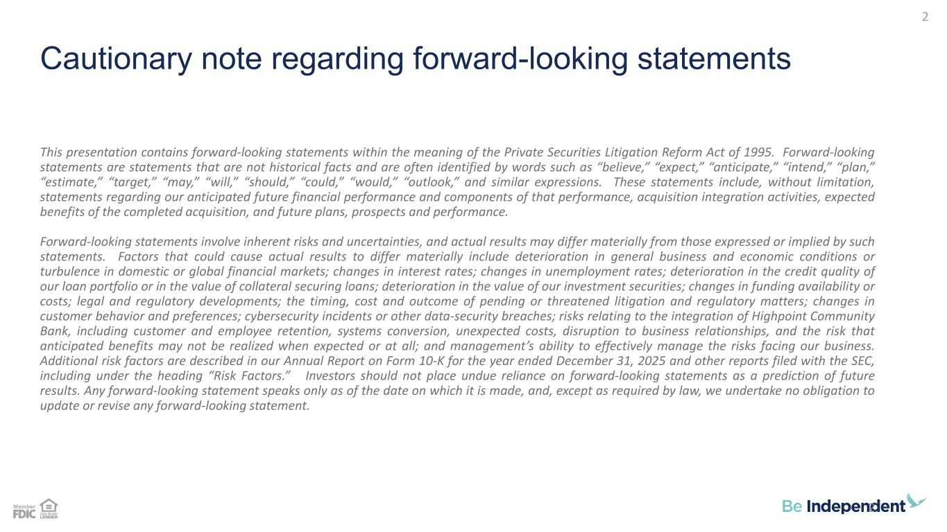
Cautionary note regarding forward-looking statements This presentation contains forward-looking statements within the meaning of the Private Securities Litigation Reform Act of 1995. Forward-looking statements are statements that are not historical facts and are often identified by words such as “believe,” “expect,” “anticipate,” “intend,” “plan,” “estimate,” “target,” “may,” “will,” “should,” “could,” “would,” “outlook,” and similar expressions. These statements include, without limitation, statements regarding our anticipated future financial performance and components of that performance, acquisition integration activities, expected benefits of the completed acquisition, and future plans, prospects and performance. Forward-looking statements involve inherent risks and uncertainties, and actual results may differ materially from those expressed or implied by such statements. Factors that could cause actual results to differ materially include deterioration in general business and economic conditions or turbulence in domestic or global financial markets; changes in interest rates; changes in unemployment rates; deterioration in the credit quality of our loan portfolio or in the value of collateral securing loans; deterioration in the value of our investment securities; changes in funding availability or costs; legal and regulatory developments; the timing, cost and outcome of pending or threatened litigation and regulatory matters; changes in customer behavior and preferences; cybersecurity incidents or other data-security breaches; risks relating to the integration of Highpoint Community Bank, including customer and employee retention, systems conversion, unexpected costs, disruption to business relationships, and the risk that anticipated benefits may not be realized when expected or at all; and management’s ability to effectively manage the risks facing our business. Additional risk factors are described in our Annual Report on Form 10-K for the year ended December 31, 2025 and other reports filed with the SEC, including under the heading “Risk Factors.” Investors should not place undue reliance on forward-looking statements as a prediction of future results. Any forward-looking statement speaks only as of the date on which it is made, and, except as required by law, we undertake no obligation to update or revise any forward-looking statement. 2 2

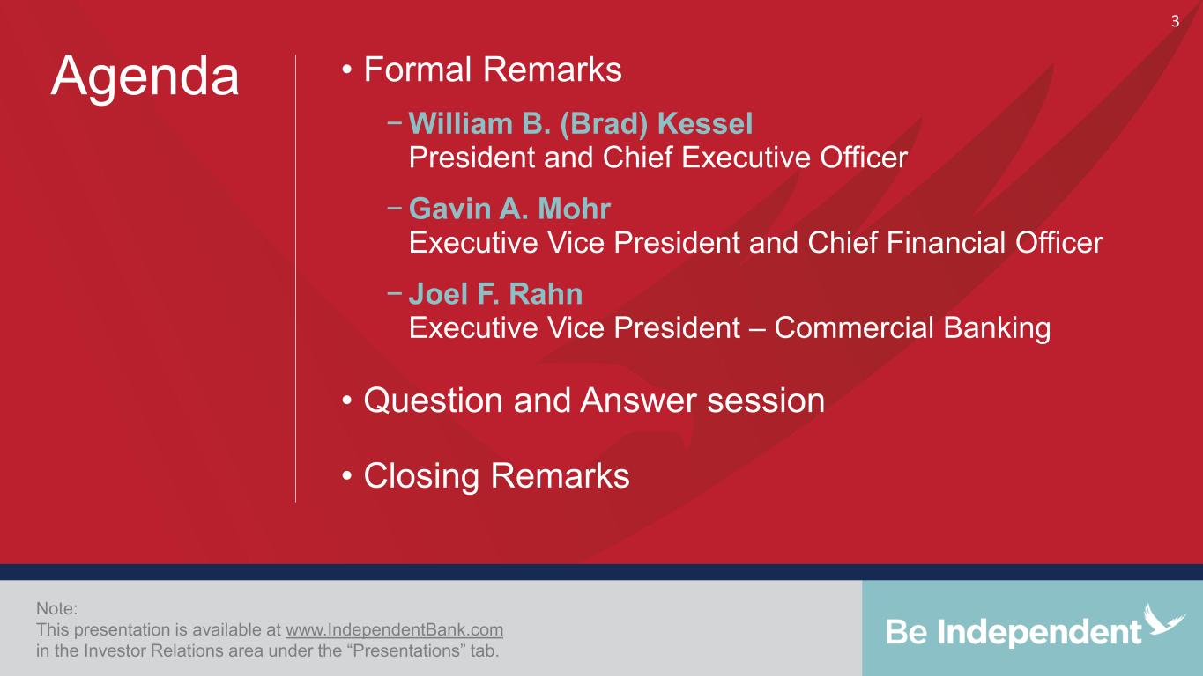
• Formal Remarks − William B. (Brad) Kessel President and Chief Executive Officer − Gavin A. Mohr Executive Vice President and Chief Financial Officer − Joel F. Rahn Executive Vice President – Commercial Banking • Question and Answer session • Closing Remarks Note: This presentation is available at www.IndependentBank.com in the Investor Relations area under the “Presentations” tab. Agenda 3

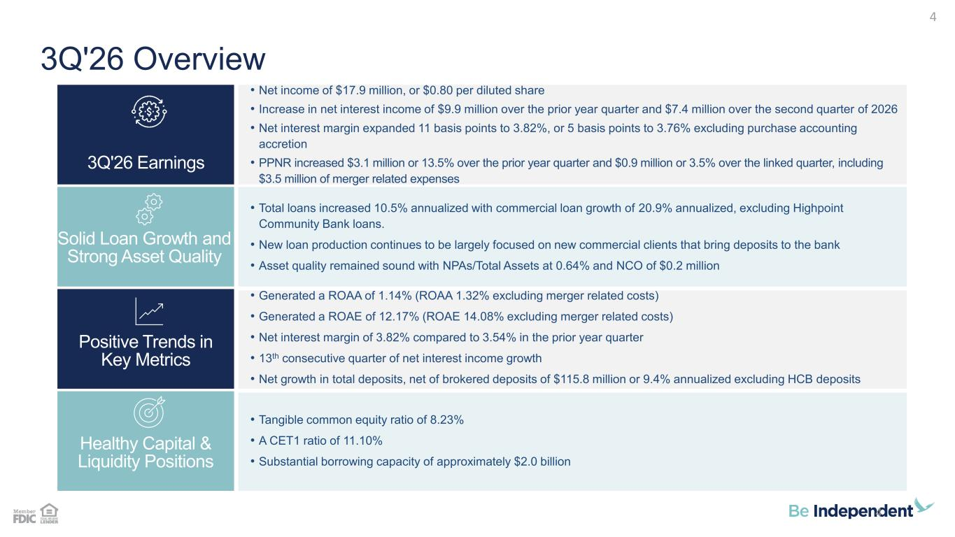
3Q'26 Overview • Total loans increased 10.5% annualized with commercial loan growth of 20.9% annualized, excluding Highpoint Community Bank loans. • New loan production continues to be largely focused on new commercial clients that bring deposits to the bank • Asset quality remained sound with NPAs/Total Assets at 0.64% and NCO of $0.2 million • Generated a ROAA of 1.14% (ROAA 1.32% excluding merger related costs) • Generated a ROAE of 12.17% (ROAE 14.08% excluding merger related costs) • Net interest margin of 3.82% compared to 3.54% in the prior year quarter • 13th consecutive quarter of net interest income growth • Net growth in total deposits, net of brokered deposits of $115.8 million or 9.4% annualized excluding HCB deposits • Tangible common equity ratio of 8.23% • A CET1 ratio of 11.10% • Substantial borrowing capacity of approximately $2.0 billion • Net income of $17.9 million, or $0.80 per diluted share • Increase in net interest income of $9.9 million over the prior year quarter and $7.4 million over the second quarter of 2026 • Net interest margin expanded 11 basis points to 3.82%, or 5 basis points to 3.76% excluding purchase accounting accretion • PPNR increased $3.1 million or 13.5% over the prior year quarter and $0.9 million or 3.5% over the linked quarter, including $3.5 million of merger related expenses Healthy Capital & Liquidity Positions Positive Trends in Key Metrics Solid Loan Growth and Strong Asset Quality 3Q'26 Earnings 4 4

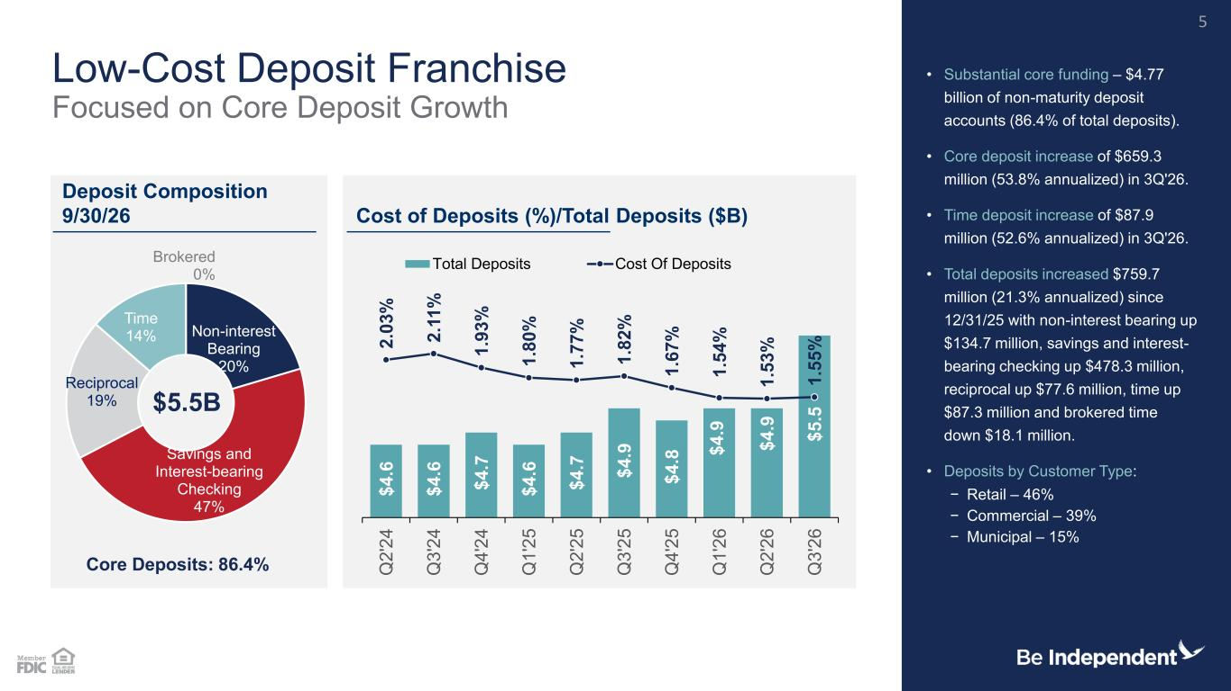
$ 4 .6 $ 4 .6 $ 4 .7 $ 4 .6 $ 4 .7 $ 4 .9 $ 4 .8 $ 4 .9 $ 4 .9 $ 5 .5 2 .0 3 % 2 .1 1 % 1 .9 3 % 1 .8 0 % 1 .7 7 % 1 .8 2 % 1 .6 7 % 1 .5 4 % 1 .5 3 % 1 .5 5 % Q 2 '2 4 Q 3 '2 4 Q 4 '2 4 Q 1 '2 5 Q 2 '2 5 Q 3 '2 5 Q 4 '2 5 Q 1 '2 6 Q 2 '2 6 Q 3 '2 6 Total Deposits Cost Of Deposits Non-interest Bearing 20% Savings and Interest-bearing Checking 47% Reciprocal 19% Time 14% Brokered 0% Low-Cost Deposit Franchise Focused on Core Deposit Growth • Substantial core funding – $4.77 billion of non-maturity deposit accounts (86.4% of total deposits). • Core deposit increase of $659.3 million (53.8% annualized) in 3Q'26. • Time deposit increase of $87.9 million (52.6% annualized) in 3Q'26. • Total deposits increased $759.7 million (21.3% annualized) since 12/31/25 with non-interest bearing up $134.7 million, savings and interest- bearing checking up $478.3 million, reciprocal up $77.6 million, time up $87.3 million and brokered time down $18.1 million. • Deposits by Customer Type: − Retail – 46% − Commercial – 39% − Municipal – 15% Deposit Composition 9/30/26 Cost of Deposits (%)/Total Deposits ($B) 5 Core Deposits: 86.4% $5.5B

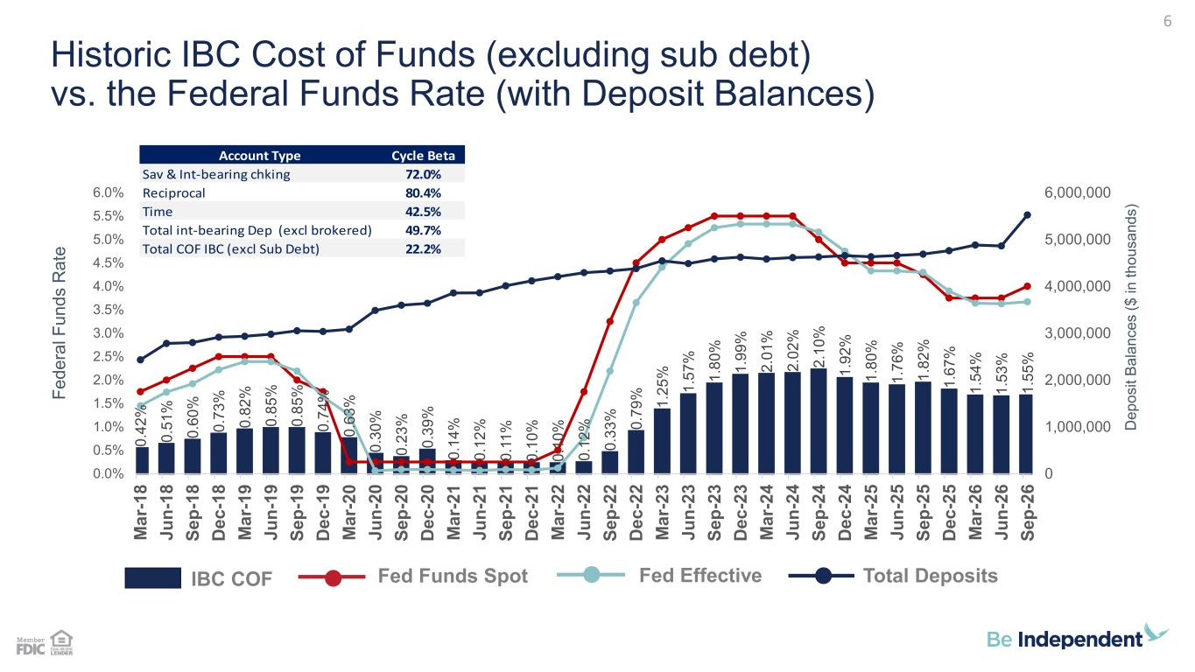
Historic IBC Cost of Funds (excluding sub debt) vs. the Federal Funds Rate (with Deposit Balances) D e p o s it B a la n c e s ( $ i n t h o u s a n d s ) 6 F e d e ra l F u n d s R a te Account Type Cycle Beta Sav & Int-bearing chking 72.0% Reciprocal 80.4% Time 42.5% Total int-bearing Dep (excl brokered) 49.7% Total COF IBC (excl Sub Debt) 22.2% IBC COF Fed Funds Spot Fed Effective Total Deposits 0 .4 2 % 0 .5 1 % 0 .6 0 % 0 .7 3 % 0 .8 2 % 0 .8 5 % 0 .8 5 % 0 .7 4 % 0 .6 3 % 0 .3 0 % 0 .2 3 % 0 .3 9 % 0 .1 4 % 0 .1 2 % 0 .1 1 % 0 .1 0 % 0 .1 0 % 0 .1 2 % 0 .3 3 % 0 .7 9 % 1 .2 5 % 1 .5 7 % 1 .8 0 % 1 .9 9 % 2 .0 1 % 2 .0 2 % 2 .1 0 % 1 .9 2 % 1 .8 0 % 1 .7 6 % 1 .8 2 % 1 .6 7 % 1 .5 4 % 1 .5 3 % 1 .5 5 % 0 1,000,000 2,000,000 3,000,000 4,000,000 5,000,000 6,000,000 0.0% 0.5% 1.0% 1.5% 2.0% 2.5% 3.0% 3.5% 4.0% 4.5% 5.0% 5.5% 6.0% M a r- 1 8 J u n -1 8 S e p -1 8 D e c -1 8 M a r- 1 9 J u n -1 9 S e p -1 9 D e c -1 9 M a r- 2 0 J u n -2 0 S e p -2 0 D e c -2 0 M a r- 2 1 J u n -2 1 S e p -2 1 D e c -2 1 M a r- 2 2 J u n -2 2 S e p -2 2 D e c -2 2 M a r- 2 3 J u n -2 3 S e p -2 3 D e c -2 3 M a r- 2 4 J u n -2 4 S e p -2 4 D e c -2 4 M a r- 2 5 J u n -2 5 S e p -2 5 D e c -2 5 M a r- 2 6 J u n -2 6 S e p -2 6

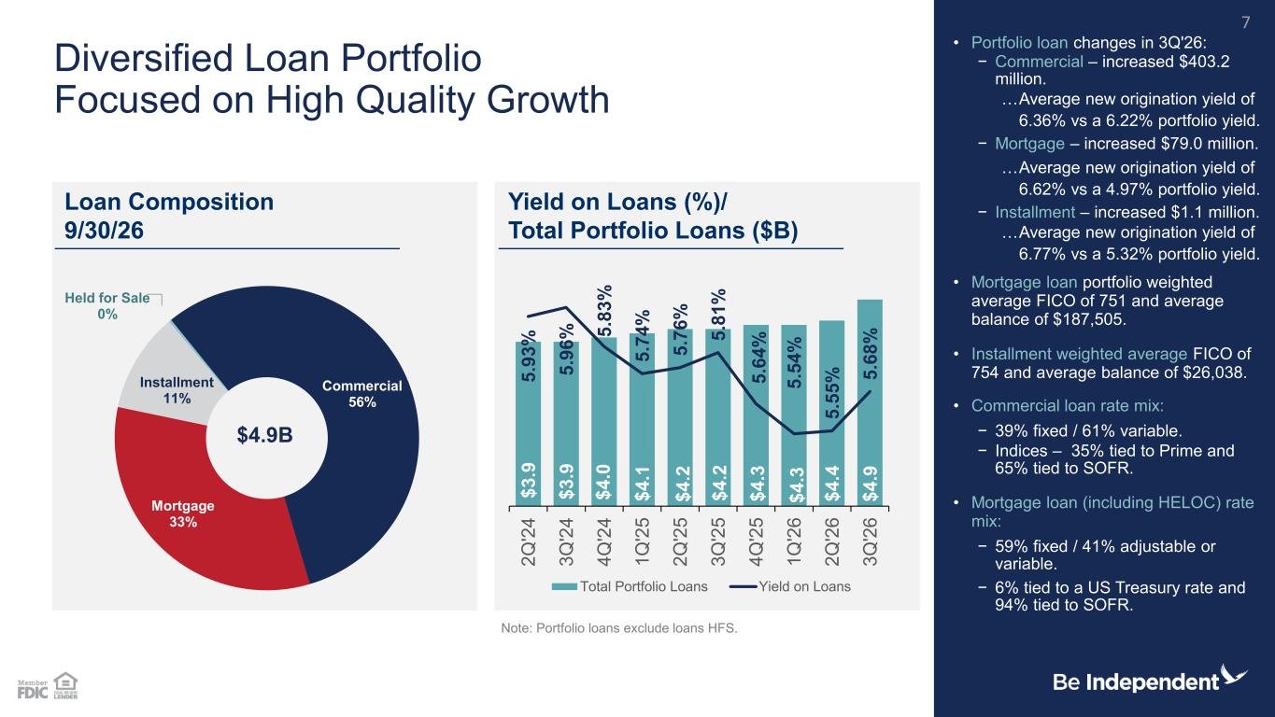
Commercial 56% Mortgage 33% Installment 11% Held for Sale 0% Diversified Loan Portfolio Focused on High Quality Growth • Portfolio loan changes in 3Q'26: − Commercial – increased $403.2 million. …Average new origination yield of 6.36% vs a 6.22% portfolio yield. − Mortgage – increased $79.0 million. …Average new origination yield of 6.62% vs a 4.97% portfolio yield. − Installment – increased $1.1 million. …Average new origination yield of 6.77% vs a 5.32% portfolio yield. • Mortgage loan portfolio weighted average FICO of 751 and average balance of $187,505. • Installment weighted average FICO of 754 and average balance of $26,038. • Commercial loan rate mix: − 39% fixed / 61% variable. − Indices – 35% tied to Prime and 65% tied to SOFR. • Mortgage loan (including HELOC) rate mix: − 59% fixed / 41% adjustable or variable. − 6% tied to a US Treasury rate and 94% tied to SOFR. Note: Portfolio loans exclude loans HFS. Loan Composition 9/30/26 Yield on Loans (%)/ Total Portfolio Loans ($B) 7 $4.9B $ 3 .9 $ 3 .9 $ 4 .0 $ 4 .1 $ 4 .2 $ 4 .2 $ 4 .3 $ 4 .3 $ 4 .4 $ 4 .9 5 .9 3 % 5 .9 6 % 5 .8 3 % 5 .7 4 % 5 .7 6 % 5 .8 1 % 5 .6 4 % 5 .5 4 % 5 .5 5 % 5 .6 8 % 2 Q '2 4 3 Q '2 4 4 Q '2 4 1 Q '2 5 2 Q '2 5 3 Q '2 5 4 Q '2 5 1 Q '2 6 2 Q '2 6 3 Q '2 6 Total Portfolio Loans Yield on Loans

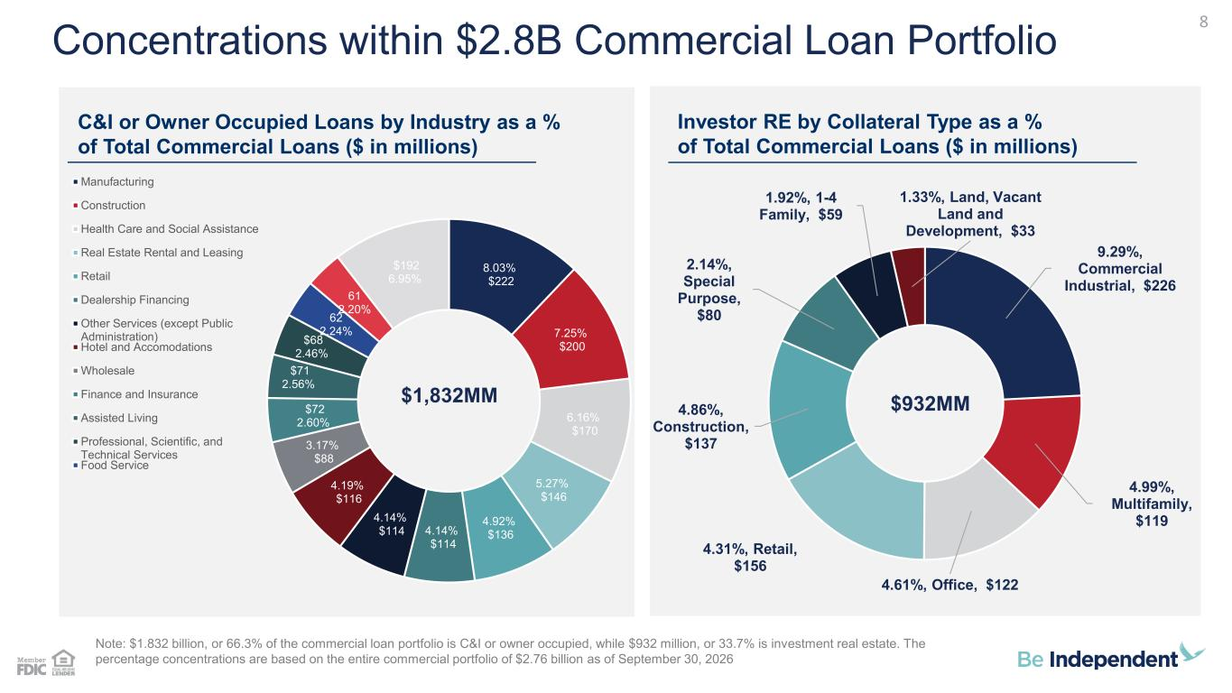
8.03% $222 7.25% $200 6.16% $170 5.27% $146 4.92% $136 4.14% $114 4.14% $114 4.19% $116 3.17% $88 $72 2.60% $71 2.56% $68 2.46% 62 2.24% 61 2.20% $192 6.95% Manufacturing Construction Health Care and Social Assistance Real Estate Rental and Leasing Retail Dealership Financing Other Services (except Public Administration) Hotel and Accomodations Wholesale Finance and Insurance Assisted Living Professional, Scientific, and Technical Services Food Service Concentrations within $2.8B Commercial Loan Portfolio C&I or Owner Occupied Loans by Industry as a % of Total Commercial Loans ($ in millions) Investor RE by Collateral Type as a % of Total Commercial Loans ($ in millions) Note: $1.832 billion, or 66.3% of the commercial loan portfolio is C&I or owner occupied, while $932 million, or 33.7% is investment real estate. The percentage concentrations are based on the entire commercial portfolio of $2.76 billion as of September 30, 2026 8 $1,832MM 9.29%, Commercial Industrial, $226 4.99%, Multifamily, $119 4.61%, Office, $122 4.31%, Retail, $156 4.86%, Construction, $137 2.14%, Special Purpose, $80 1.92%, 1-4 Family, $59 1.33%, Land, Vacant Land and Development, $33 $932MM

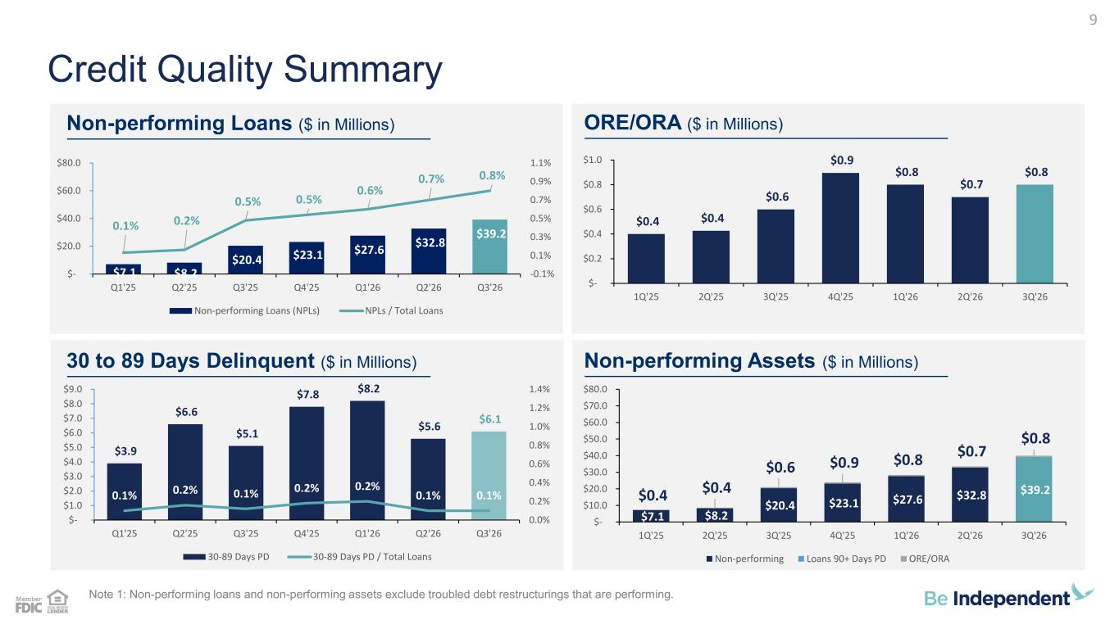
$7.1 $8.2 $20.4 $23.1 $27.6 $32.8 $39.2 $0.4 $0.4 $0.6 $0.9 $0.8 $0.7 $0.8 $- $10.0 $20.0 $30.0 $40.0 $50.0 $60.0 $70.0 $80.0 1Q'25 2Q'25 3Q'25 4Q'25 1Q'26 2Q'26 3Q'26 Non-performing Loans 90+ Days PD ORE/ORA $3.9 $6.6 $5.1 $7.8 $8.2 $5.6 $6.1 0.1% 0.2% 0.1% 0.2% 0.2% 0.1% 0.1% 0.0% 0.2% 0.4% 0.6% 0.8% 1.0% 1.2% 1.4% $- $1.0 $2.0 $3.0 $4.0 $5.0 $6.0 $7.0 $8.0 $9.0 Q1'25 Q2'25 Q3'25 Q4'25 Q1'26 Q2'26 Q3'26 30-89 Days PD 30-89 Days PD / Total Loans $0.4 $0.4 $0.6 $0.9 $0.8 $0.7 $0.8 $- $0.2 $0.4 $0.6 $0.8 $1.0 1Q'25 2Q'25 3Q'25 4Q'25 1Q'26 2Q'26 3Q'26 $7.1 $8.2 $20.4 $23.1 $27.6 $32.8 $39.2 0.1% 0.2% 0.5% 0.5% 0.6% 0.7% 0.8% -0.1% 0.1% 0.3% 0.5% 0.7% 0.9% 1.1% $- $20.0 $40.0 $60.0 $80.0 Q1'25 Q2'25 Q3'25 Q4'25 Q1'26 Q2'26 Q3'26 Non-performing Loans (NPLs) NPLs / Total Loans Note 1: Non-performing loans and non-performing assets exclude troubled debt restructurings that are performing. Credit Quality Summary Non-performing Loans ($ in Millions) ORE/ORA ($ in Millions) 30 to 89 Days Delinquent ($ in Millions) Non-performing Assets ($ in Millions) 9

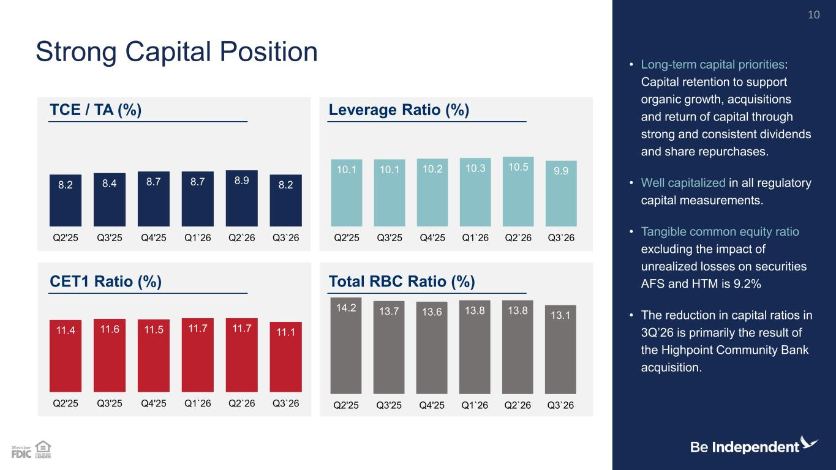
14.2 13.7 13.6 13.8 13.8 13.1 Q2'25 Q3'25 Q4'25 Q1`26 Q2`26 Q3`26 11.4 11.6 11.5 11.7 11.7 11.1 Q2'25 Q3'25 Q4'25 Q1`26 Q2`26 Q3`26 10.1 10.1 10.2 10.3 10.5 9.9 Q2'25 Q3'25 Q4'25 Q1`26 Q2`26 Q3`26 8.2 8.4 8.7 8.7 8.9 8.2 Q2'25 Q3'25 Q4'25 Q1`26 Q2`26 Q3`26 • Long-term capital priorities: Capital retention to support organic growth, acquisitions and return of capital through strong and consistent dividends and share repurchases. • Well capitalized in all regulatory capital measurements. • Tangible common equity ratio excluding the impact of unrealized losses on securities AFS and HTM is 9.2% • The reduction in capital ratios in 3Q’26 is primarily the result of the Highpoint Community Bank acquisition. Strong Capital Position TCE / TA (%) Leverage Ratio (%) CET1 Ratio (%) Total RBC Ratio (%) 10

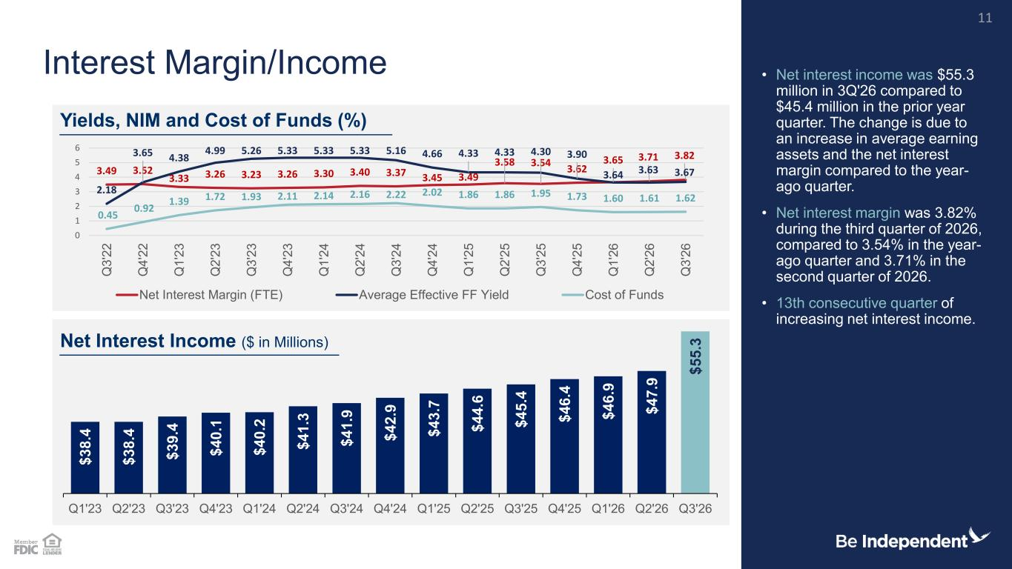
$ 3 8 .4 $ 3 8 .4 $ 3 9 .4 $ 4 0 .1 $ 4 0 .2 $ 4 1 .3 $ 4 1 .9 $ 4 2 .9 $ 4 3 .7 $ 4 4 .6 $ 4 5 .4 $ 4 6 .4 $ 4 6 .9 $ 4 7 .9 $ 5 5 .3 Q1'23 Q2'23 Q3'23 Q4'23 Q1'24 Q2'24 Q3'24 Q4'24 Q1'25 Q2'25 Q3'25 Q4'25 Q1'26 Q2'26 Q3'26 3.49 3.52 3.33 3.26 3.23 3.26 3.30 3.40 3.37 3.45 3.49 3.58 3.54 3.62 3.65 3.71 3.82 2.18 3.65 4.38 4.99 5.26 5.33 5.33 5.33 5.16 4.66 4.33 4.33 4.30 3.90 3.64 3.63 3.67 0.45 0.92 1.39 1.72 1.93 2.11 2.14 2.16 2.22 2.02 1.86 1.86 1.95 1.73 1.60 1.61 1.62 0 1 2 3 4 5 6 Q 3 '2 2 Q 4 '2 2 Q 1 '2 3 Q 2 '2 3 Q 3 '2 3 Q 4 '2 3 Q 1 '2 4 Q 2 '2 4 Q 3 '2 4 Q 4 '2 4 Q 1 '2 5 Q 2 '2 5 Q 3 '2 5 Q 4 '2 5 Q 1 '2 6 Q 2 '2 6 Q 3 '2 6 Net Interest Margin (FTE) Average Effective FF Yield Cost of Funds Net Interest Margin/Income • Net interest income was $55.3 million in 3Q'26 compared to $45.4 million in the prior year quarter. The change is due to an increase in average earning assets and the net interest margin compared to the year- ago quarter. • Net interest margin was 3.82% during the third quarter of 2026, compared to 3.54% in the year- ago quarter and 3.71% in the second quarter of 2026. • 13th consecutive quarter of increasing net interest income. Yields, NIM and Cost of Funds (%) Net Interest Income ($ in Millions) 11

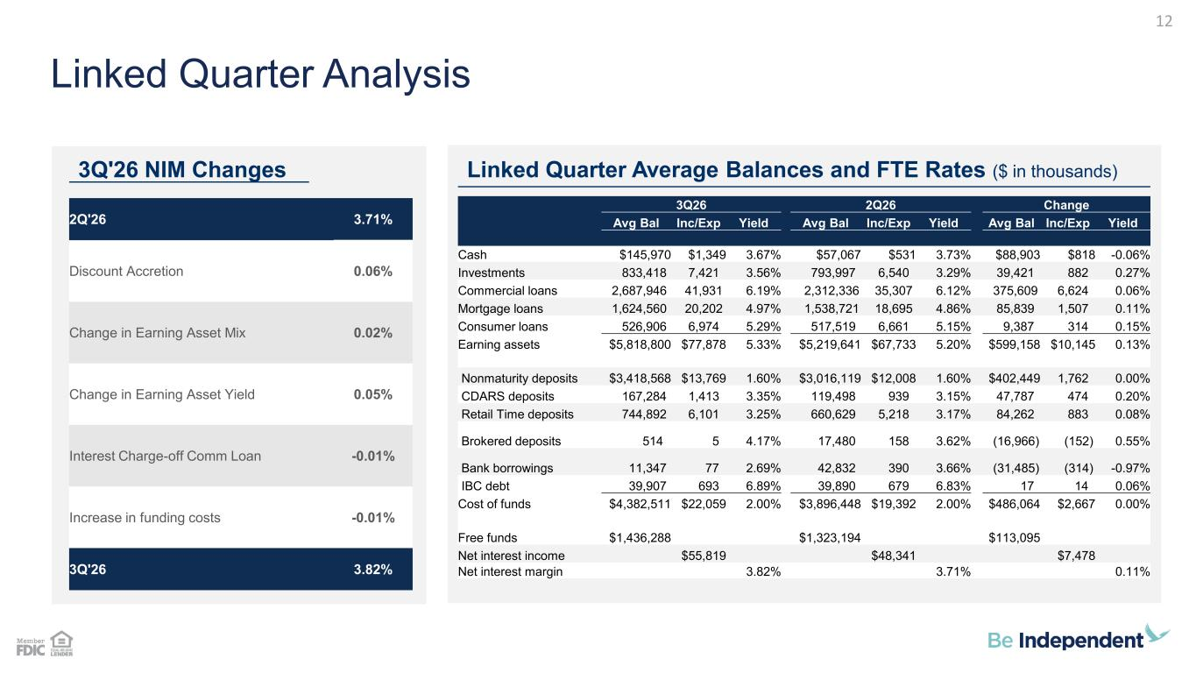
3Q26 2Q26 Change Avg Bal Inc/Exp Yield Avg Bal Inc/Exp Yield Avg Bal Inc/Exp Yield Cash $145,970 $1,349 3.67% $57,067 $531 3.73% $88,903 $818 -0.06% Investments 833,418 7,421 3.56% 793,997 6,540 3.29% 39,421 882 0.27% Commercial loans 2,687,946 41,931 6.19% 2,312,336 35,307 6.12% 375,609 6,624 0.06% Mortgage loans 1,624,560 20,202 4.97% 1,538,721 18,695 4.86% 85,839 1,507 0.11% Consumer loans 526,906 6,974 5.29% 517,519 6,661 5.15% 9,387 314 0.15% Earning assets $5,818,800 $77,878 5.33% $5,219,641 $67,733 5.20% $599,158 $10,145 0.13% Nonmaturity deposits $3,418,568 $13,769 1.60% $3,016,119 $12,008 1.60% $402,449 1,762 0.00% CDARS deposits 167,284 1,413 3.35% 119,498 939 3.15% 47,787 474 0.20% Retail Time deposits 744,892 6,101 3.25% 660,629 5,218 3.17% 84,262 883 0.08% Brokered deposits 514 5 4.17% 17,480 158 3.62% (16,966) (152) 0.55% Bank borrowings 11,347 77 2.69% 42,832 390 3.66% (31,485) (314) -0.97% IBC debt 39,907 693 6.89% 39,890 679 6.83% 17 14 0.06% Cost of funds $4,382,511 $22,059 2.00% $3,896,448 $19,392 2.00% $486,064 $2,667 0.00% Free funds $1,436,288 $1,323,194 $113,095 Net interest income $55,819 $48,341 $7,478 Net interest margin 3.82% 3.71% 0.11% 3Q'26 NIM Changes Linked Quarter Average Balances and FTE Rates ($ in thousands) Linked Quarter Analysis 12 2Q'26 3.71% Discount Accretion 0.06% Change in Earning Asset Mix 0.02% Change in Earning Asset Yield 0.05% Interest Charge-off Comm Loan -0.01% Increase in funding costs -0.01% 3Q'26 3.82%

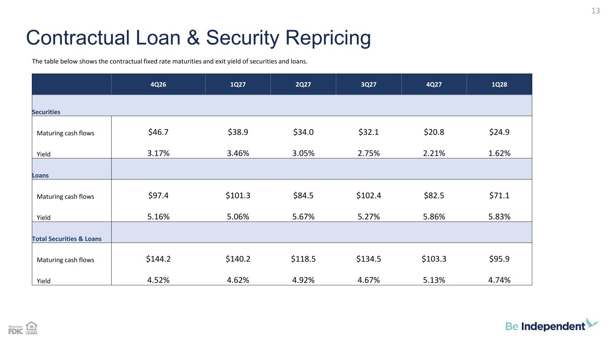
Contractual Loan & Security Repricing 13 The table below shows the contractual fixed rate maturities and exit yield of securities and loans. 4Q26 1Q27 2Q27 3Q27 4Q27 1Q28 Securities Maturing cash flows $46.7 $38.9 $34.0 $32.1 $20.8 $24.9 Yield 3.17% 3.46% 3.05% 2.75% 2.21% 1.62% Loans Maturing cash flows $97.4 $101.3 $84.5 $102.4 $82.5 $71.1 Yield 5.16% 5.06% 5.67% 5.27% 5.86% 5.83% Total Securities & Loans Maturing cash flows $144.2 $140.2 $118.5 $134.5 $103.3 $95.9 Yield 4.52% 4.62% 4.92% 4.67% 5.13% 4.74%

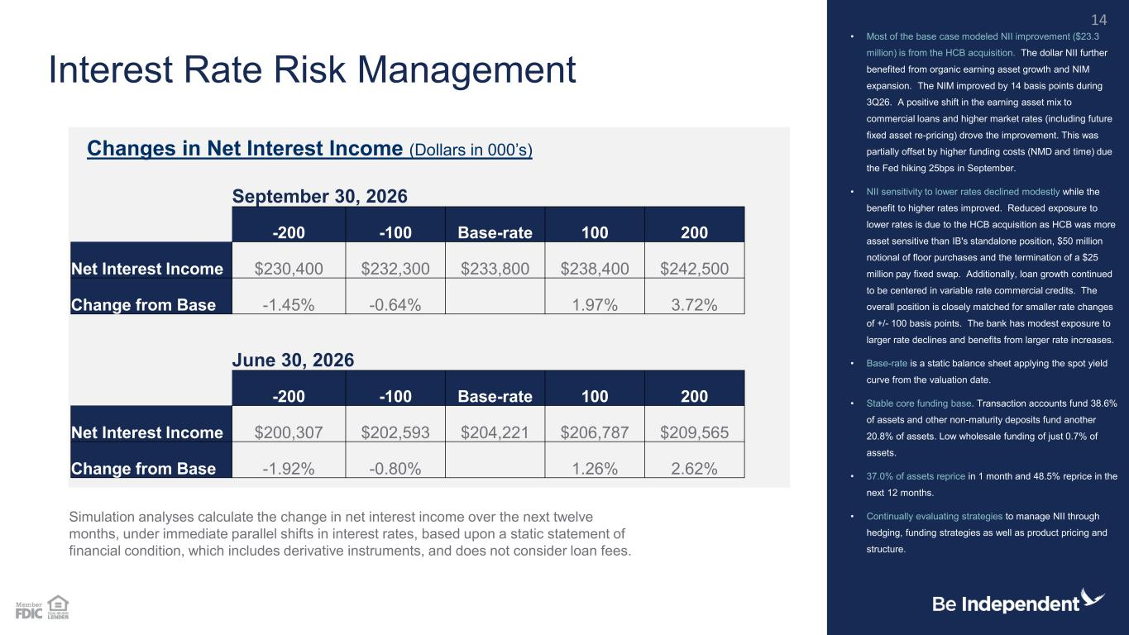
September 30, 2026 -200 -100 Base-rate 100 200 Net Interest Income $230,400 $232,300 $233,800 $238,400 $242,500 Change from Base -1.45% -0.64% 1.97% 3.72% June 30, 2026 -200 -100 Base-rate 100 200 Net Interest Income $200,307 $202,593 $204,221 $206,787 $209,565 Change from Base -1.92% -0.80% 1.26% 2.62% Interest Rate Risk Management • Most of the base case modeled NII improvement ($23.3 million) is from the HCB acquisition. The dollar NII further benefited from organic earning asset growth and NIM expansion. The NIM improved by 14 basis points during 3Q26. A positive shift in the earning asset mix to commercial loans and higher market rates (including future fixed asset re-pricing) drove the improvement. This was partially offset by higher funding costs (NMD and time) due the Fed hiking 25bps in September. • NII sensitivity to lower rates declined modestly while the benefit to higher rates improved. Reduced exposure to lower rates is due to the HCB acquisition as HCB was more asset sensitive than IB's standalone position, $50 million notional of floor purchases and the termination of a $25 million pay fixed swap. Additionally, loan growth continued to be centered in variable rate commercial credits. The overall position is closely matched for smaller rate changes of +/- 100 basis points. The bank has modest exposure to larger rate declines and benefits from larger rate increases. • Base-rate is a static balance sheet applying the spot yield curve from the valuation date. • Stable core funding base. Transaction accounts fund 38.6% of assets and other non-maturity deposits fund another 20.8% of assets. Low wholesale funding of just 0.7% of assets. • 37.0% of assets reprice in 1 month and 48.5% reprice in the next 12 months. • Continually evaluating strategies to manage NII through hedging, funding strategies as well as product pricing and structure. Changes in Net Interest Income (Dollars in 000’s) Simulation analyses calculate the change in net interest income over the next twelve months, under immediate parallel shifts in interest rates, based upon a static statement of financial condition, which includes derivative instruments, and does not consider loan fees. 14

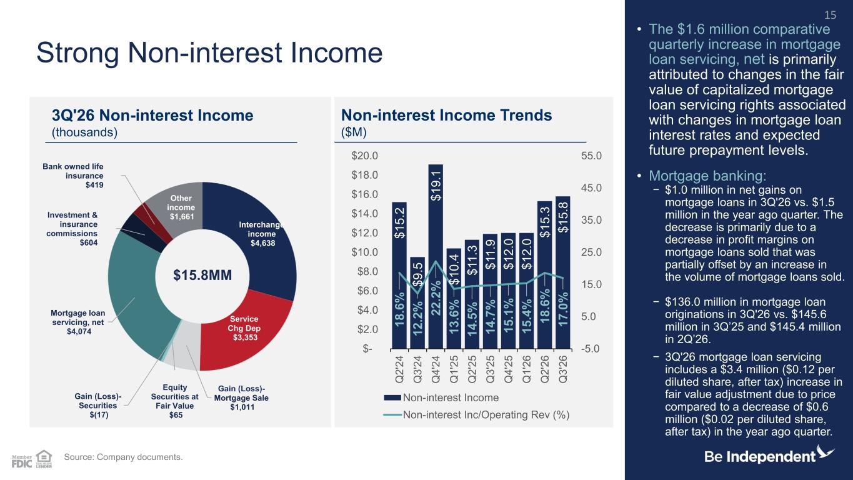
$ 1 5 .2 $ 9 .5 $ 1 9 .1 $ 1 0 .4 $ 1 1 .3 $ 1 1 .9 $ 1 2 .0 $ 1 2 .0 $ 1 5 .3 $ 1 5 .8 1 8 .6 % 1 2 .2 % 2 2 .2 % 1 3 .6 % 1 4 .5 % 1 4 .7 % 1 5 .1 % 1 5 .4 % 1 8 .6 % 1 7 .0 % -5.0 5.0 15.0 25.0 35.0 45.0 55.0 $- $2.0 $4.0 $6.0 $8.0 $10.0 $12.0 $14.0 $16.0 $18.0 $20.0 Q 2 '2 4 Q 3 '2 4 Q 4 '2 4 Q 1 '2 5 Q 2 '2 5 Q 3 '2 5 Q 4 '2 5 Q 1 '2 6 Q 2 '2 6 Q 3 '2 6 Non-interest Income Non-interest Inc/Operating Rev (%) Interchange income $4,638 Service Chg Dep $3,353 Gain (Loss)- Mortgage Sale $1,011 Equity Securities at Fair Value $65 Gain (Loss)- Securities $(17) Mortgage loan servicing, net $4,074 Investment & insurance commissions $604 Bank owned life insurance $419 Other income $1,661 Strong Non-interest Income • The $1.6 million comparative quarterly increase in mortgage loan servicing, net is primarily attributed to changes in the fair value of capitalized mortgage loan servicing rights associated with changes in mortgage loan interest rates and expected future prepayment levels. • Mortgage banking: − $1.0 million in net gains on mortgage loans in 3Q'26 vs. $1.5 million in the year ago quarter. The decrease is primarily due to a decrease in profit margins on mortgage loans sold that was partially offset by an increase in the volume of mortgage loans sold. − $136.0 million in mortgage loan originations in 3Q'26 vs. $145.6 million in 3Q’25 and $145.4 million in 2Q’26. − 3Q'26 mortgage loan servicing includes a $3.4 million ($0.12 per diluted share, after tax) increase in fair value adjustment due to price compared to a decrease of $0.6 million ($0.02 per diluted share, after tax) in the year ago quarter. Source: Company documents. 3Q'26 Non-interest Income (thousands) Non-interest Income Trends ($M) 15 $15.8MM

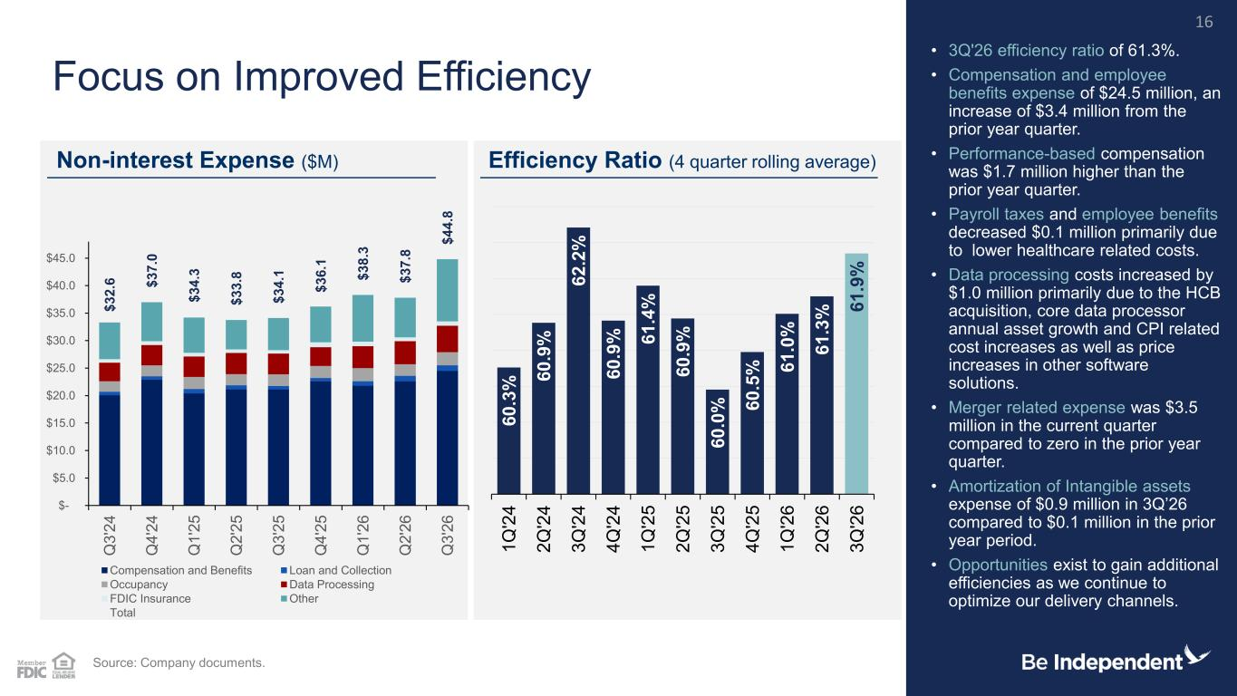
6 0 .3 % 6 0 .9 % 6 2 .2 % 6 0 .9 % 6 1 .4 % 6 0 .9 % 6 0 .0 % 6 0 .5 % 6 1 .0 % 6 1 .3 % 6 1 .9 % 1 Q '2 4 2 Q '2 4 3 Q '2 4 4 Q '2 4 1 Q '2 5 2 Q '2 5 3 Q '2 5 4 Q '2 5 1 Q '2 6 2 Q '2 6 3 Q '2 6 $ 3 2 .6 $ 3 7 .0 $ 3 4 .3 $ 3 3 .8 $ 3 4 .1 $ 3 6 .1 $ 3 8 .3 $ 3 7 .8 $ 4 4 .8 $- $5.0 $10.0 $15.0 $20.0 $25.0 $30.0 $35.0 $40.0 $45.0 Q 3 '2 4 Q 4 '2 4 Q 1 '2 5 Q 2 '2 5 Q 3 '2 5 Q 4 '2 5 Q 1 '2 6 Q 2 '2 6 Q 3 '2 6 Compensation and Benefits Loan and Collection Occupancy Data Processing FDIC Insurance Other Total Focus on Improved Efficiency • 3Q'26 efficiency ratio of 61.3%. • Compensation and employee benefits expense of $24.5 million, an increase of $3.4 million from the prior year quarter. • Performance-based compensation was $1.7 million higher than the prior year quarter. • Payroll taxes and employee benefits decreased $0.1 million primarily due to lower healthcare related costs. • Data processing costs increased by $1.0 million primarily due to the HCB acquisition, core data processor annual asset growth and CPI related cost increases as well as price increases in other software solutions. • Merger related expense was $3.5 million in the current quarter compared to zero in the prior year quarter. • Amortization of Intangible assets expense of $0.9 million in 3Q’26 compared to $0.1 million in the prior year period. • Opportunities exist to gain additional efficiencies as we continue to optimize our delivery channels. Non-interest Expense ($M) Efficiency Ratio (4 quarter rolling average) Source: Company documents. 16

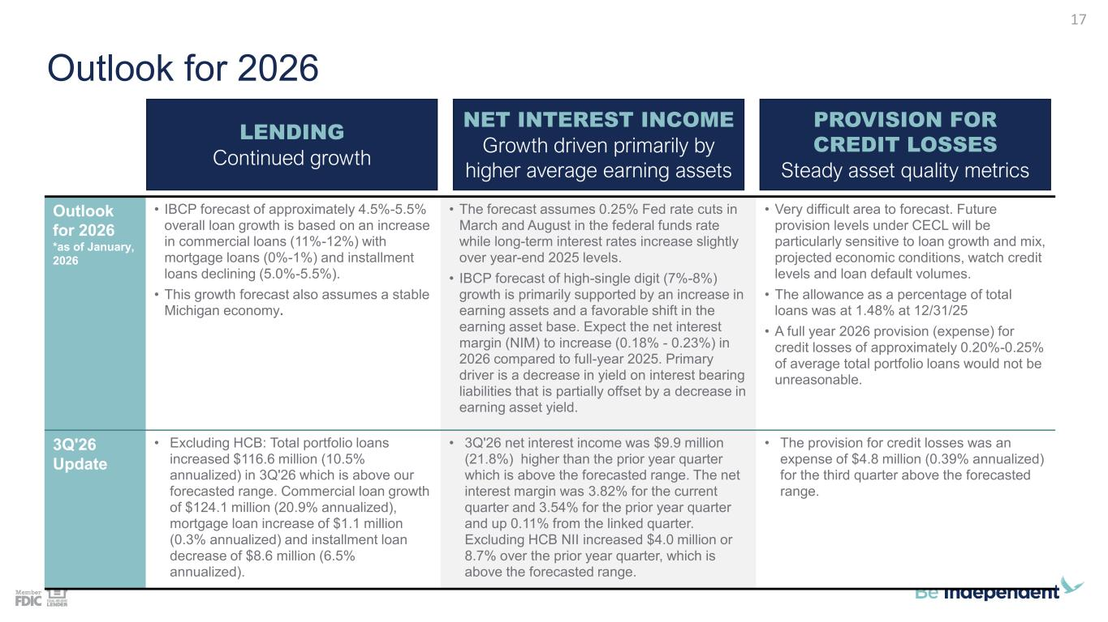
Outlook for 2026 Outlook for 2026 *as of January, 2026 • IBCP forecast of approximately 4.5%-5.5% overall loan growth is based on an increase in commercial loans (11%-12%) with mortgage loans (0%-1%) and installment loans declining (5.0%-5.5%). • This growth forecast also assumes a stable Michigan economy. • The forecast assumes 0.25% Fed rate cuts in March and August in the federal funds rate while long-term interest rates increase slightly over year-end 2025 levels. • IBCP forecast of high-single digit (7%-8%) growth is primarily supported by an increase in earning assets and a favorable shift in the earning asset base. Expect the net interest margin (NIM) to increase (0.18% - 0.23%) in 2026 compared to full-year 2025. Primary driver is a decrease in yield on interest bearing liabilities that is partially offset by a decrease in earning asset yield. • Very difficult area to forecast. Future provision levels under CECL will be particularly sensitive to loan growth and mix, projected economic conditions, watch credit levels and loan default volumes. • The allowance as a percentage of total loans was at 1.48% at 12/31/25 • A full year 2026 provision (expense) for credit losses of approximately 0.20%-0.25% of average total portfolio loans would not be unreasonable. 3Q'26 Update • Excluding HCB: Total portfolio loans increased $116.6 million (10.5% annualized) in 3Q'26 which is above our forecasted range. Commercial loan growth of $124.1 million (20.9% annualized), mortgage loan increase of $1.1 million (0.3% annualized) and installment loan decrease of $8.6 million (6.5% annualized). • 3Q'26 net interest income was $9.9 million (21.8%) higher than the prior year quarter which is above the forecasted range. The net interest margin was 3.82% for the current quarter and 3.54% for the prior year quarter and up 0.11% from the linked quarter. Excluding HCB NII increased $4.0 million or 8.7% over the prior year quarter, which is above the forecasted range. • The provision for credit losses was an expense of $4.8 million (0.39% annualized) for the third quarter above the forecasted range. LENDING Continued growth NET INTEREST INCOME Growth driven primarily by higher average earning assets PROVISION FOR CREDIT LOSSES Steady asset quality metrics 17

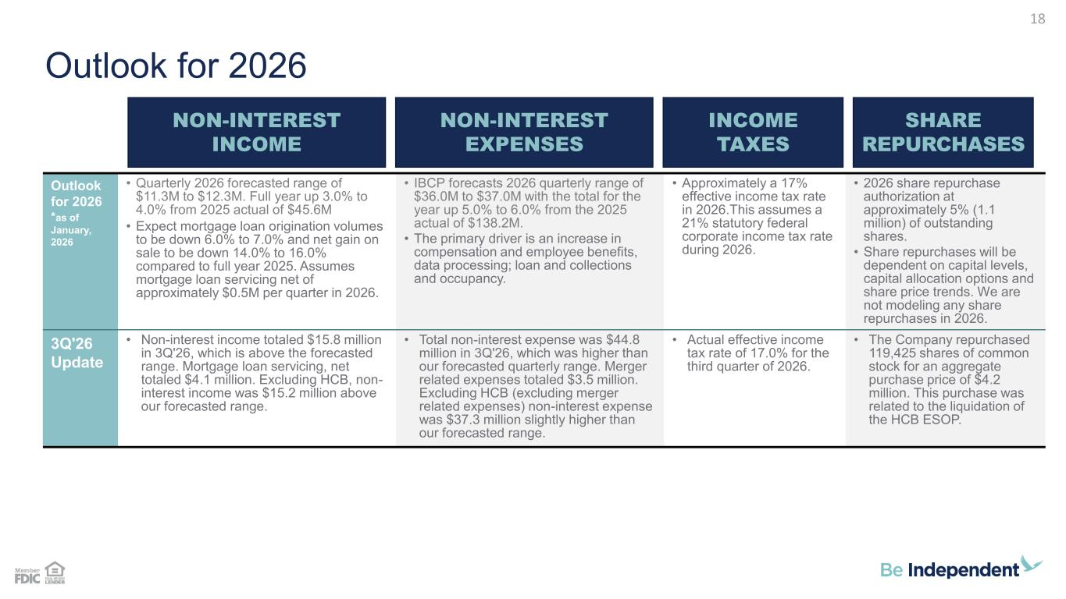
Outlook for 2026 Outlook for 2026 *as of January, 2026 • Quarterly 2026 forecasted range of $11.3M to $12.3M. Full year up 3.0% to 4.0% from 2025 actual of $45.6M • Expect mortgage loan origination volumes to be down 6.0% to 7.0% and net gain on sale to be down 14.0% to 16.0% compared to full year 2025. Assumes mortgage loan servicing net of approximately $0.5M per quarter in 2026. • IBCP forecasts 2026 quarterly range of $36.0M to $37.0M with the total for the year up 5.0% to 6.0% from the 2025 actual of $138.2M. • The primary driver is an increase in compensation and employee benefits, data processing; loan and collections and occupancy. • Approximately a 17% effective income tax rate in 2026.This assumes a 21% statutory federal corporate income tax rate during 2026. • 2026 share repurchase authorization at approximately 5% (1.1 million) of outstanding shares. • Share repurchases will be dependent on capital levels, capital allocation options and share price trends. We are not modeling any share repurchases in 2026. 3Q'26 Update • Non-interest income totaled $15.8 million in 3Q'26, which is above the forecasted range. Mortgage loan servicing, net totaled $4.1 million. Excluding HCB, non- interest income was $15.2 million above our forecasted range. • Total non-interest expense was $44.8 million in 3Q'26, which was higher than our forecasted quarterly range. Merger related expenses totaled $3.5 million. Excluding HCB (excluding merger related expenses) non-interest expense was $37.3 million slightly higher than our forecasted range. • Actual effective income tax rate of 17.0% for the third quarter of 2026. • The Company repurchased 119,425 shares of common stock for an aggregate purchase price of $4.2 million. This purchase was related to the liquidation of the HCB ESOP. NON-INTEREST INCOME NON-INTEREST EXPENSES INCOME TAXES SHARE REPURCHASES 18

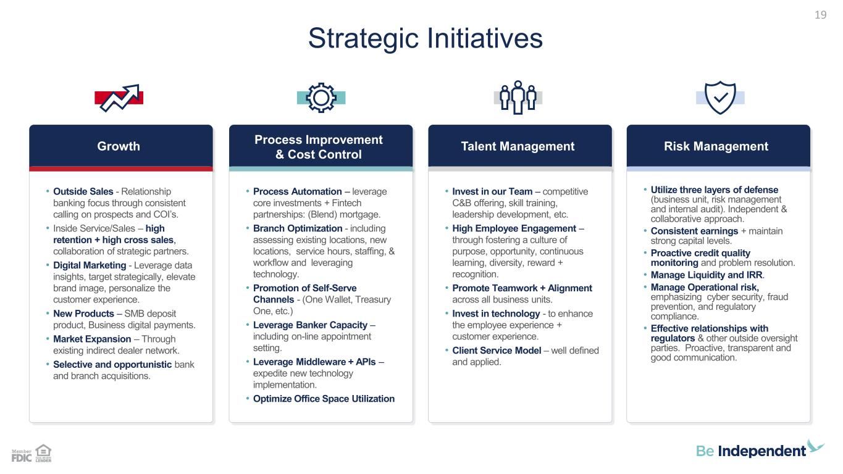
Strategic Initiatives 19 Growth • Outside Sales - Relationship banking focus through consistent calling on prospects and COI’s. • Inside Service/Sales – high retention + high cross sales, collaboration of strategic partners. • Digital Marketing - Leverage data insights, target strategically, elevate brand image, personalize the customer experience. • New Products – SMB deposit product, Business digital payments. • Market Expansion – Through existing indirect dealer network. • Selective and opportunistic bank and branch acquisitions. Process Improvement & Cost Control • Process Automation – leverage core investments + Fintech partnerships: (Blend) mortgage. • Branch Optimization - including assessing existing locations, new locations, service hours, staffing, & workflow and leveraging technology. • Promotion of Self-Serve Channels - (One Wallet, Treasury One, etc.) • Leverage Banker Capacity – including on-line appointment setting. • Leverage Middleware + APIs – expedite new technology implementation. • Optimize Office Space Utilization Talent Management • Invest in our Team – competitive C&B offering, skill training, leadership development, etc. • High Employee Engagement – through fostering a culture of purpose, opportunity, continuous learning, diversity, reward + recognition. • Promote Teamwork + Alignment across all business units. • Invest in technology - to enhance the employee experience + customer experience. • Client Service Model – well defined and applied. Risk Management • Utilize three layers of defense (business unit, risk management and internal audit). Independent & collaborative approach. • Consistent earnings + maintain strong capital levels. • Proactive credit quality monitoring and problem resolution. • Manage Liquidity and IRR. • Manage Operational risk, emphasizing cyber security, fraud prevention, and regulatory compliance. • Effective relationships with regulators & other outside oversight parties. Proactive, transparent and good communication.

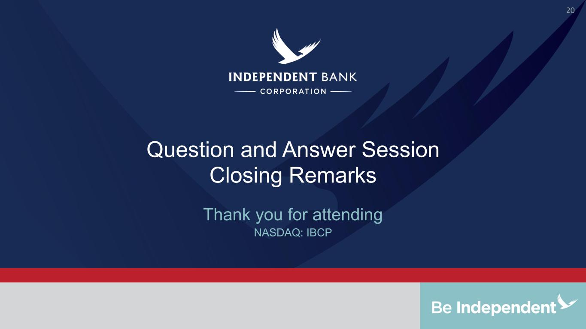
Question and Answer Session Closing Remarks NASDAQ: IBCP Thank you for attending 20

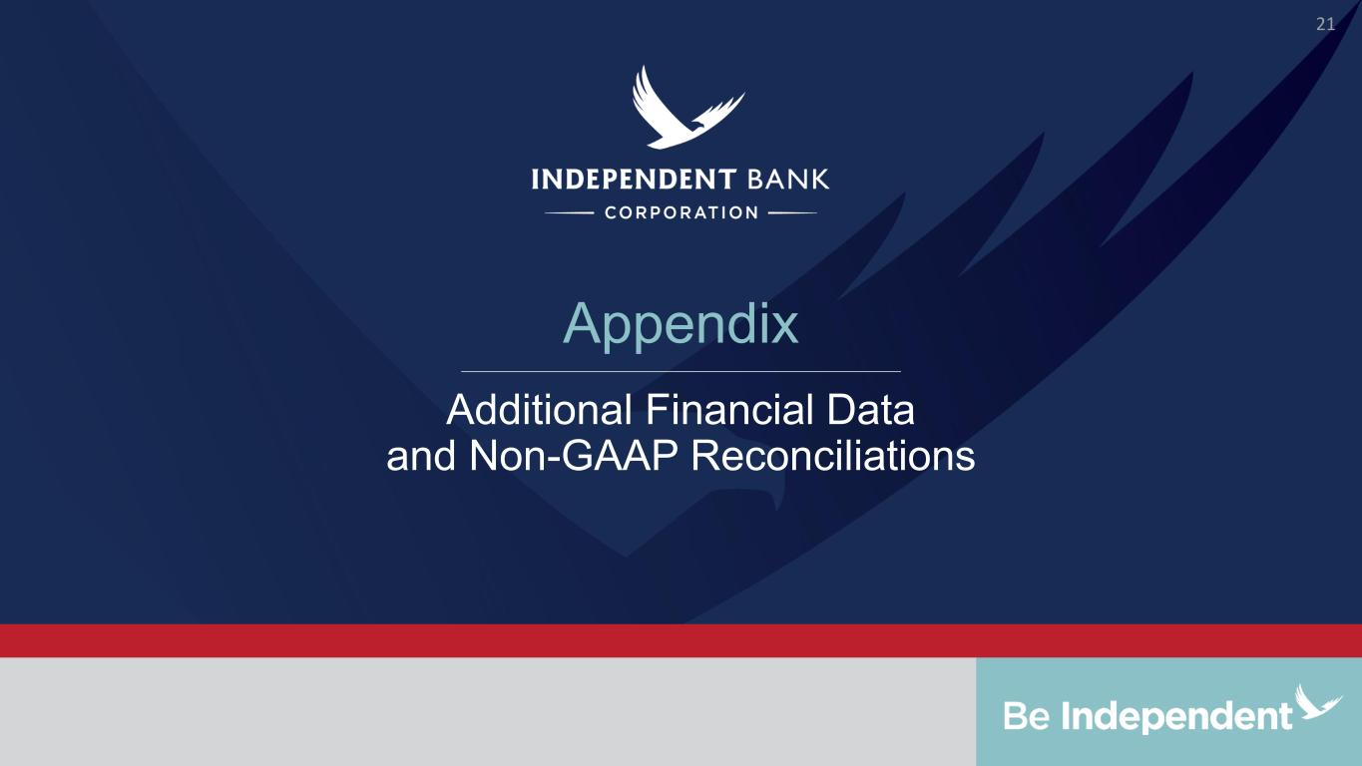
Appendix Additional Financial Data and Non-GAAP Reconciliations 21

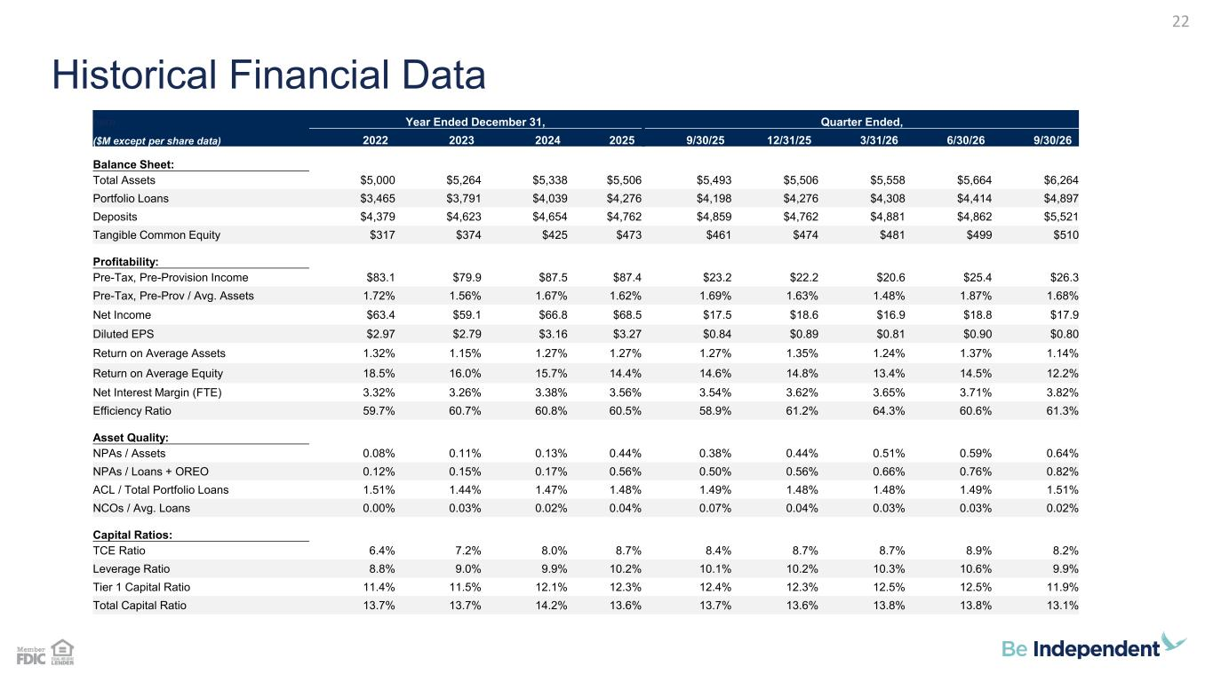
Historical Financial Data 22 here Year Ended December 31, Quarter Ended, ($M except per share data) 2022 2023 2024 2025 9/30/25 12/31/25 3/31/26 6/30/26 9/30/26 Balance Sheet: Total Assets $5,000 $5,264 $5,338 $5,506 $5,493 $5,506 $5,558 $5,664 $6,264 Portfolio Loans $3,465 $3,791 $4,039 $4,276 $4,198 $4,276 $4,308 $4,414 $4,897 Deposits $4,379 $4,623 $4,654 $4,762 $4,859 $4,762 $4,881 $4,862 $5,521 Tangible Common Equity $317 $374 $425 $473 $461 $474 $481 $499 $510 Profitability: Pre-Tax, Pre-Provision Income $83.1 $79.9 $87.5 $87.4 $23.2 $22.2 $20.6 $25.4 $26.3 Pre-Tax, Pre-Prov / Avg. Assets 1.72% 1.56% 1.67% 1.62% 1.69% 1.63% 1.48% 1.87% 1.68% Net Income $63.4 $59.1 $66.8 $68.5 $17.5 $18.6 $16.9 $18.8 $17.9 Diluted EPS $2.97 $2.79 $3.16 $3.27 $0.84 $0.89 $0.81 $0.90 $0.80 Return on Average Assets 1.32% 1.15% 1.27% 1.27% 1.27% 1.35% 1.24% 1.37% 1.14% Return on Average Equity 18.5% 16.0% 15.7% 14.4% 14.6% 14.8% 13.4% 14.5% 12.2% Net Interest Margin (FTE) 3.32% 3.26% 3.38% 3.56% 3.54% 3.62% 3.65% 3.71% 3.82% Efficiency Ratio 59.7% 60.7% 60.8% 60.5% 58.9% 61.2% 64.3% 60.6% 61.3% Asset Quality: NPAs / Assets 0.08% 0.11% 0.13% 0.44% 0.38% 0.44% 0.51% 0.59% 0.64% NPAs / Loans + OREO 0.12% 0.15% 0.17% 0.56% 0.50% 0.56% 0.66% 0.76% 0.82% ACL / Total Portfolio Loans 1.51% 1.44% 1.47% 1.48% 1.49% 1.48% 1.48% 1.49% 1.51% NCOs / Avg. Loans 0.00% 0.03% 0.02% 0.04% 0.07% 0.04% 0.03% 0.03% 0.02% Capital Ratios: TCE Ratio 6.4% 7.2% 8.0% 8.7% 8.4% 8.7% 8.7% 8.9% 8.2% Leverage Ratio 8.8% 9.0% 9.9% 10.2% 10.1% 10.2% 10.3% 10.6% 9.9% Tier 1 Capital Ratio 11.4% 11.5% 12.1% 12.3% 12.4% 12.3% 12.5% 12.5% 11.9% Total Capital Ratio 13.7% 13.7% 14.2% 13.6% 13.7% 13.6% 13.8% 13.8% 13.1%

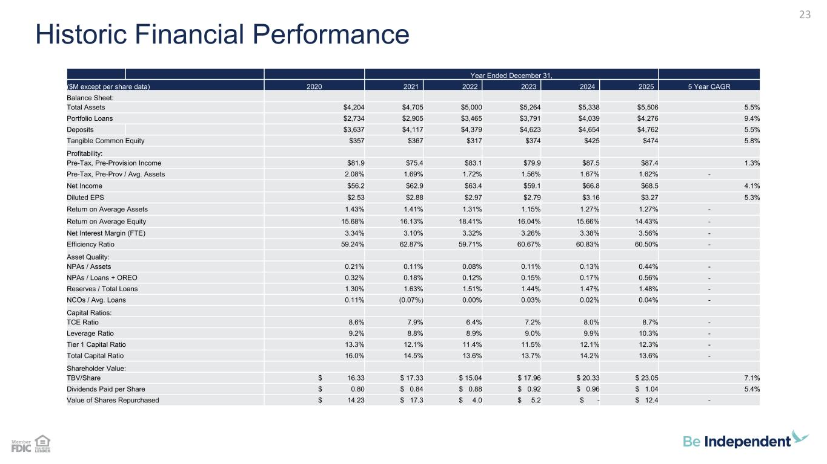
23 Historic Financial Performance Year Ended December 31, ($M except per share data) 2020 2021 2022 2023 2024 2025 5 Year CAGR Balance Sheet: Total Assets $4,204 $4,705 $5,000 $5,264 $5,338 $5,506 5.5% Portfolio Loans $2,734 $2,905 $3,465 $3,791 $4,039 $4,276 9.4% Deposits $3,637 $4,117 $4,379 $4,623 $4,654 $4,762 5.5% Tangible Common Equity $357 $367 $317 $374 $425 $474 5.8% Profitability: Pre-Tax, Pre-Provision Income $81.9 $75.4 $83.1 $79.9 $87.5 $87.4 1.3% Pre-Tax, Pre-Prov / Avg. Assets 2.08% 1.69% 1.72% 1.56% 1.67% 1.62% - Net Income $56.2 $62.9 $63.4 $59.1 $66.8 $68.5 4.1% Diluted EPS $2.53 $2.88 $2.97 $2.79 $3.16 $3.27 5.3% Return on Average Assets 1.43% 1.41% 1.31% 1.15% 1.27% 1.27% - Return on Average Equity 15.68% 16.13% 18.41% 16.04% 15.66% 14.43% - Net Interest Margin (FTE) 3.34% 3.10% 3.32% 3.26% 3.38% 3.56% - Efficiency Ratio 59.24% 62.87% 59.71% 60.67% 60.83% 60.50% - Asset Quality: NPAs / Assets 0.21% 0.11% 0.08% 0.11% 0.13% 0.44% - NPAs / Loans + OREO 0.32% 0.18% 0.12% 0.15% 0.17% 0.56% - Reserves / Total Loans 1.30% 1.63% 1.51% 1.44% 1.47% 1.48% - NCOs / Avg. Loans 0.11% (0.07%) 0.00% 0.03% 0.02% 0.04% - Capital Ratios: TCE Ratio 8.6% 7.9% 6.4% 7.2% 8.0% 8.7% - Leverage Ratio 9.2% 8.8% 8.9% 9.0% 9.9% 10.3% - Tier 1 Capital Ratio 13.3% 12.1% 11.4% 11.5% 12.1% 12.3% - Total Capital Ratio 16.0% 14.5% 13.6% 13.7% 14.2% 13.6% - Shareholder Value: TBV/Share $ 16.33 $ 17.33 $ 15.04 $ 17.96 $ 20.33 $ 23.05 7.1% Dividends Paid per Share $ 0.80 $ 0.84 $ 0.88 $ 0.92 $ 0.96 $ 1.04 5.4% Value of Shares Repurchased $ 14.23 $ 17.3 $ 4.0 $ 5.2 $ - $ 12.4 -

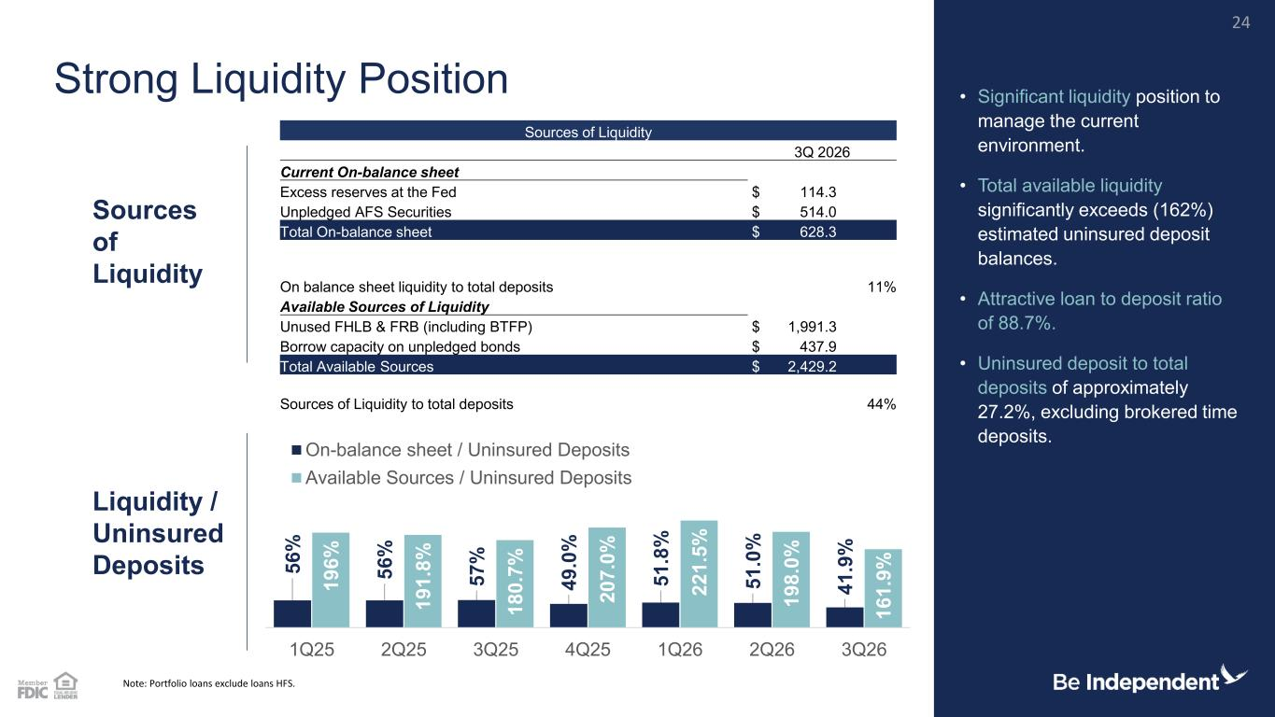
5 6 % 5 6 % 5 7 % 4 9 .0 % 5 1 .8 % 5 1 .0 % 4 1 .9 % 1 9 6 % 1 9 1 .8 % 1 8 0 .7 % 2 0 7 .0 % 2 2 1 .5 % 1 9 8 .0 % 1 6 1 .9 % 1Q25 2Q25 3Q25 4Q25 1Q26 2Q26 3Q26 On-balance sheet / Uninsured Deposits Available Sources / Uninsured Deposits Sources of Liquidity 3Q 2026 Current On-balance sheet Excess reserves at the Fed $ 114.3 Unpledged AFS Securities $ 514.0 Total On-balance sheet $ 628.3 On balance sheet liquidity to total deposits 11% Available Sources of Liquidity Unused FHLB & FRB (including BTFP) $ 1,991.3 Borrow capacity on unpledged bonds $ 437.9 Total Available Sources $ 2,429.2 Sources of Liquidity to total deposits 44% Note: Portfolio loans exclude loans HFS. Liquidity / Uninsured Deposits Strong Liquidity Position • Significant liquidity position to manage the current environment. • Total available liquidity significantly exceeds (162%) estimated uninsured deposit balances. • Attractive loan to deposit ratio of 88.7%. • Uninsured deposit to total deposits of approximately 27.2%, excluding brokered time deposits. Sources of Liquidity 24

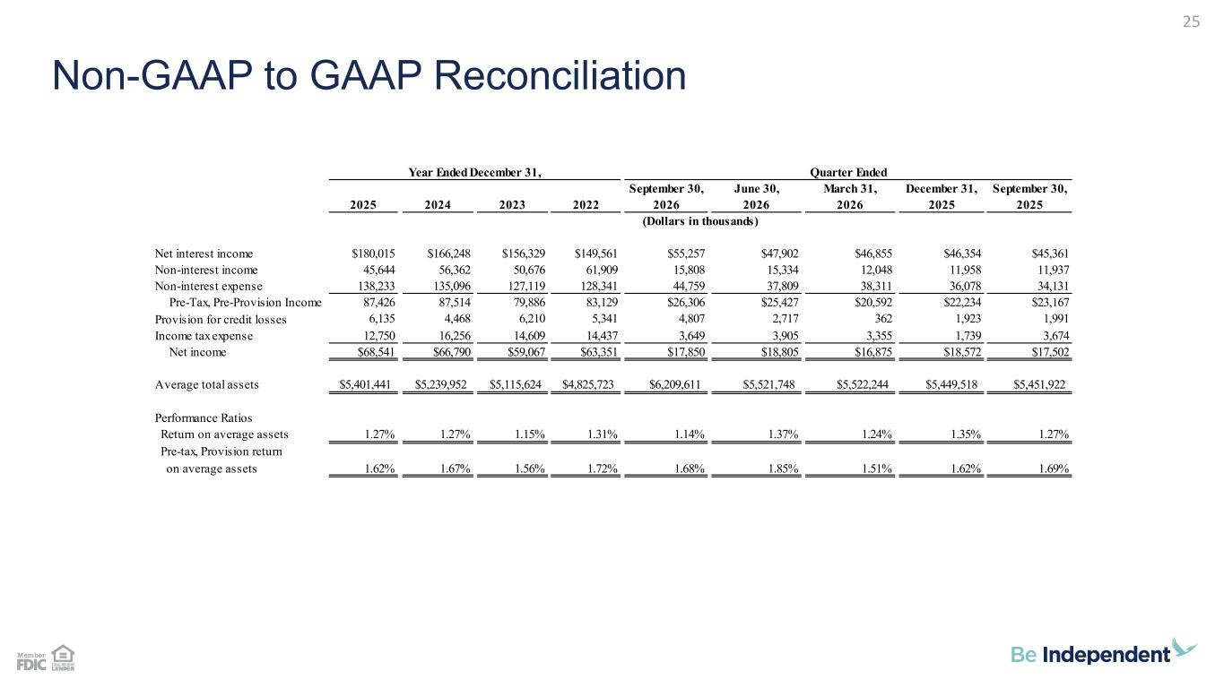
Non-GAAP to GAAP Reconciliation 25 September 30, June 30, March 31, December 31, September 30, 2025 2024 2023 2022 2026 2026 2026 2025 2025 Net interest income $180,015 $166,248 $156,329 $149,561 $55,257 $47,902 $46,855 $46,354 $45,361 Non-interest income 45,644 56,362 50,676 61,909 15,808 15,334 12,048 11,958 11,937 Non-interest expense 138,233 135,096 127,119 128,341 44,759 37,809 38,311 36,078 34,131 Pre-Tax, Pre-Provision Income 87,426 87,514 79,886 83,129 $26,306 $25,427 $20,592 $22,234 $23,167 Provision for credit losses 6,135 4,468 6,210 5,341 4,807 2,717 362 1,923 1,991 Income tax expense 12,750 16,256 14,609 14,437 3,649 3,905 3,355 1,739 3,674 Net income $68,541 $66,790 $59,067 $63,351 $17,850 $18,805 $16,875 $18,572 $17,502 Average total assets $5,401,441 $5,239,952 $5,115,624 $4,825,723 $6,209,611 $5,521,748 $5,522,244 $5,449,518 $5,451,922 Performance Ratios Return on average assets 1.27% 1.27% 1.15% 1.31% 1.14% 1.37% 1.24% 1.35% 1.27% Pre-tax, Provision return on average assets 1.62% 1.67% 1.56% 1.72% 1.68% 1.85% 1.51% 1.62% 1.69% Year Ended December 31, (Dollars in thousands) Quarter Ended

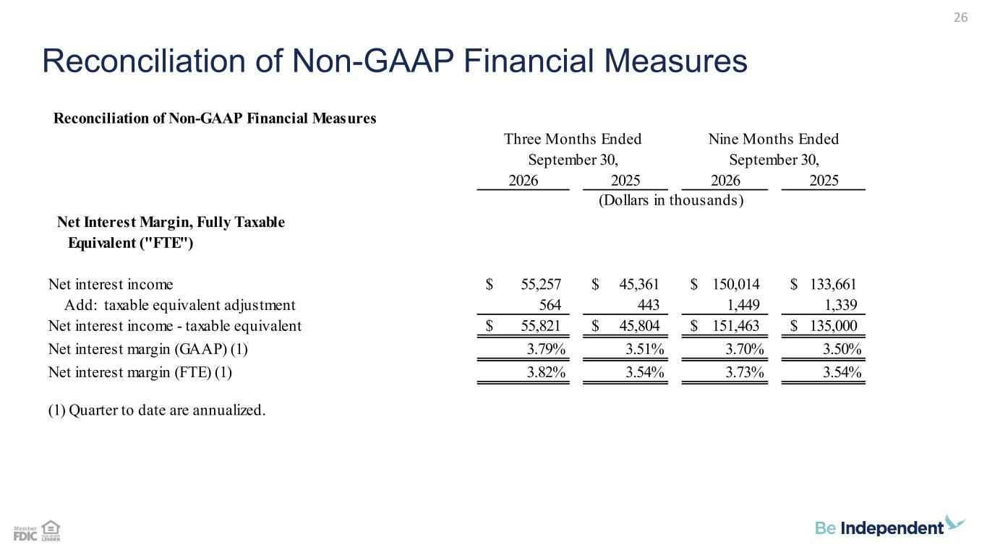
Reconciliation of Non-GAAP Financial Measures 26 Reconciliation of Non-GAAP Financial Measures 2026 2025 2026 2025 Net Interest Margin, Fully Taxable Equivalent ("FTE") Net interest income 55,257$ 45,361$ 150,014$ 133,661$ Add: taxable equivalent adjustment 564 443 1,449 1,339 Net interest income - taxable equivalent 55,821$ 45,804$ 151,463$ 135,000$ Net interest margin (GAAP) (1) 3.79% 3.51% 3.70% 3.50% Net interest margin (FTE) (1) 3.82% 3.54% 3.73% 3.54% (1) Quarter to date are annualized. Three Months Ended Nine Months Ended September 30, September 30, (Dollars in thousands)

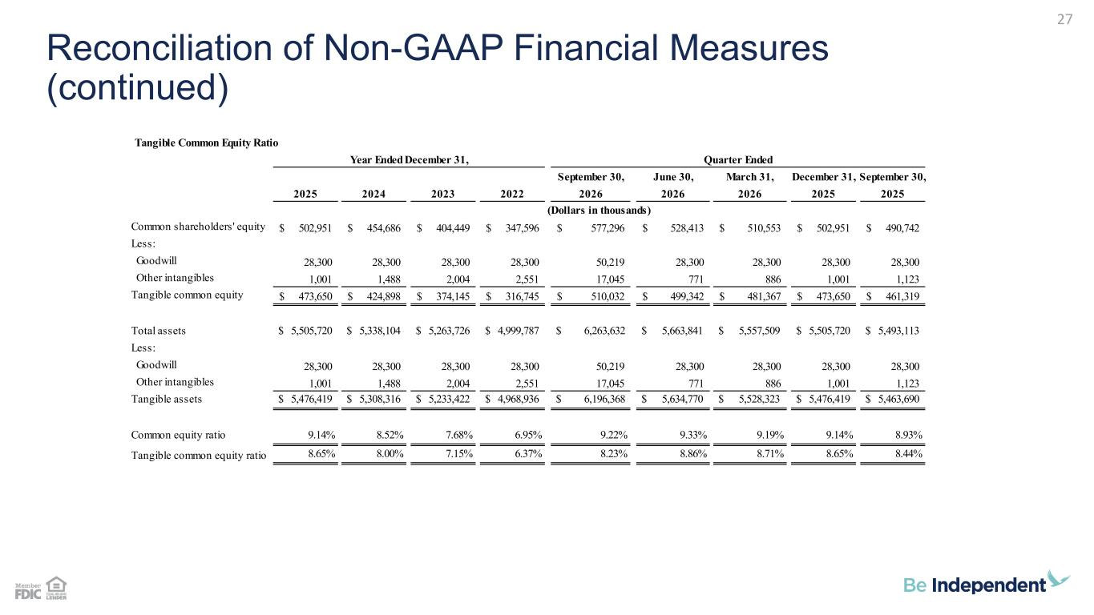
Reconciliation of Non-GAAP Financial Measures (continued) 27 Tangible Common Equity Ratio September 30, June 30, March 31, December 31, September 30, 2025 2024 2023 2022 2026 2026 2026 2025 2025 Common shareholders' equity 502,951$ 454,686$ 404,449$ 347,596$ 577,296$ 528,413$ 510,553$ 502,951$ 490,742$ Less: Goodwill 28,300 28,300 28,300 28,300 50,219 28,300 28,300 28,300 28,300 Other intangibles 1,001 1,488 2,004 2,551 17,045 771 886 1,001 1,123 Tangible common equity 473,650$ 424,898$ 374,145$ 316,745$ 510,032$ 499,342$ 481,367$ 473,650$ 461,319$ Total assets $ 5,505,720 $ 5,338,104 $ 5,263,726 $ 4,999,787 $ 6,263,632 $ 5,663,841 $ 5,557,509 $ 5,505,720 $ 5,493,113 Less: Goodwill 28,300 28,300 28,300 28,300 50,219 28,300 28,300 28,300 28,300 Other intangibles 1,001 1,488 2,004 2,551 17,045 771 886 1,001 1,123 Tangible assets $ 5,476,419 $ 5,308,316 $ 5,233,422 $ 4,968,936 $ 6,196,368 $ 5,634,770 $ 5,528,323 $ 5,476,419 $ 5,463,690 Common equity ratio 9.14% 8.52% 7.68% 6.95% 9.22% 9.33% 9.19% 9.14% 8.93% Tangible common equity ratio 8.65% 8.00% 7.15% 6.37% 8.23% 8.86% 8.71% 8.65% 8.44% Year Ended December 31, (Dollars in thousands) Quarter Ended

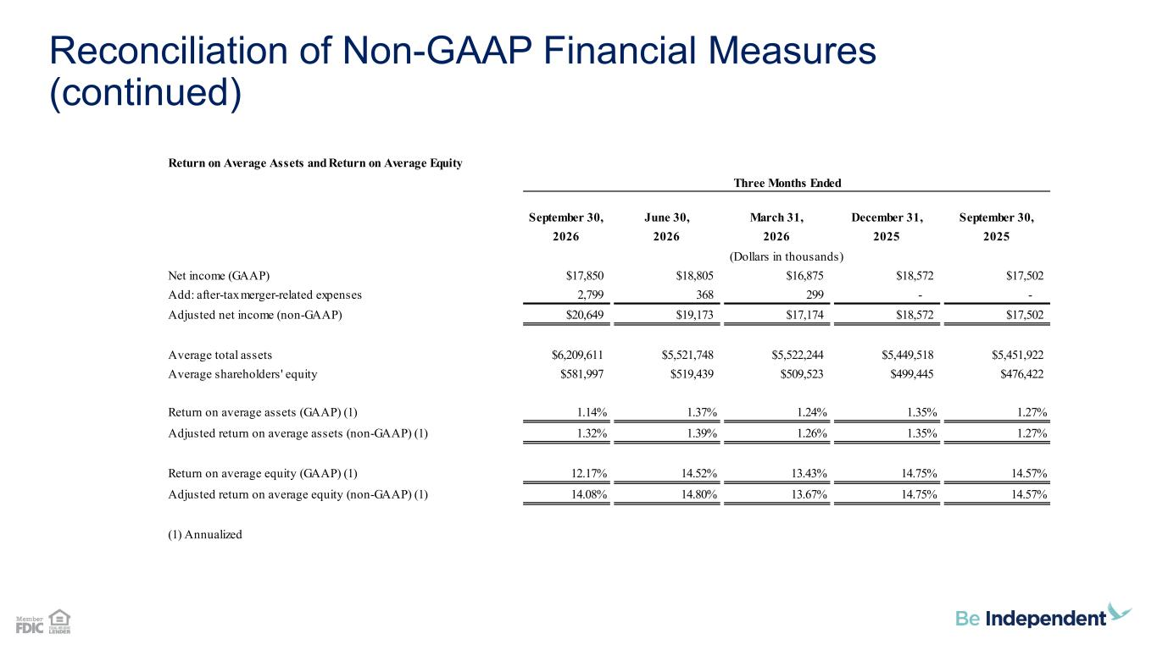
Reconciliation of Non-GAAP Financial Measures (continued) Return on Average Assets and Return on Average Equity September 30, June 30, March 31, December 31, September 30, 2026 2026 2026 2025 2025 Net income (GAAP) $17,850 $18,805 $16,875 $18,572 $17,502 Add: after-tax merger-related expenses 2,799 368 299 - - Adjusted net income (non-GAAP) $20,649 $19,173 $17,174 $18,572 $17,502 Average total assets $6,209,611 $5,521,748 $5,522,244 $5,449,518 $5,451,922 Average shareholders' equity $581,997 $519,439 $509,523 $499,445 $476,422 Return on average assets (GAAP) (1) 1.14% 1.37% 1.24% 1.35% 1.27% Adjusted return on average assets (non-GAAP) (1) 1.32% 1.39% 1.26% 1.35% 1.27% Return on average equity (GAAP) (1) 12.17% 14.52% 13.43% 14.75% 14.57% Adjusted return on average equity (non-GAAP) (1) 14.08% 14.80% 13.67% 14.75% 14.57% (1) Annualized Three Months Ended (Dollars in thousands)

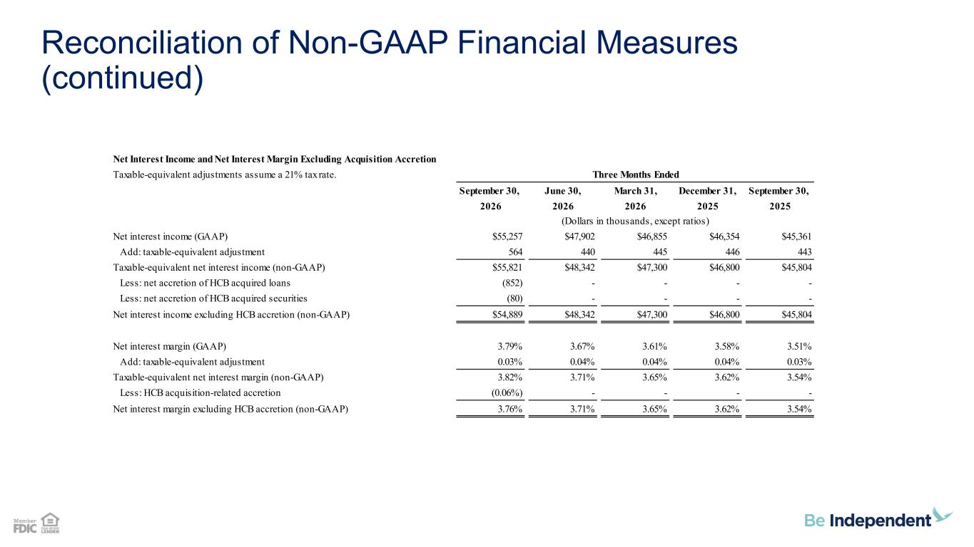
Reconciliation of Non-GAAP Financial Measures (continued) Net Interest Income and Net Interest Margin Excluding Acquisition Accretion Taxable-equivalent adjustments assume a 21% tax rate. September 30, June 30, March 31, December 31, September 30, 2026 2026 2026 2025 2025 Net interest income (GAAP) $55,257 $47,902 $46,855 $46,354 $45,361 Add: taxable-equivalent adjustment 564 440 445 446 443 Taxable-equivalent net interest income (non-GAAP) $55,821 $48,342 $47,300 $46,800 $45,804 Less: net accretion of HCB acquired loans (852) - - - - Less: net accretion of HCB acquired securities (80) - - - - Net interest income excluding HCB accretion (non-GAAP) $54,889 $48,342 $47,300 $46,800 $45,804 Net interest margin (GAAP) 3.79% 3.67% 3.61% 3.58% 3.51% Add: taxable-equivalent adjustment 0.03% 0.04% 0.04% 0.04% 0.03% Taxable-equivalent net interest margin (non-GAAP) 3.82% 3.71% 3.65% 3.62% 3.54% Less: HCB acquisition-related accretion (0.06%) - - - - Net interest margin excluding HCB accretion (non-GAAP) 3.76% 3.71% 3.65% 3.62% 3.54% Three Months Ended (Dollars in thousands, except ratios)

